2023 CALL FOR PROJECTS &
GRANT APPLICATION

FOR THE RALEIGH CARY URBANIZED AREA’S TRANSPORTATION FOR ELDERLY PERSONS AND PERSONS WITH DISABILITIES FUNDING PROGRAM (SECTION 5310)

Contents
Introduction 3
Funding Availability 3
Project Eligibility 3
Traditional Capital Expenses 4
Other Eligible Capital and Operating Expenses 7
Projects that Exceed the Requirements of the ADA 7
Public Transportation Projects that Improve Accessibility 8
Alternatives to Public Transportation that Assist Elderly persons and Persons with disabilities with Transportation 9
Map of Urban Area 11
Application Process 12
Application Submission 12
Project Evaluation Criteria 13
Scoring Criteria 15
5310 Funding Program Application 16
Part I – Funding Request 16
Part II – Project Narrative 17
Part III – Proposed Project Budget 24
Part IV - Modified Total Direct Cost (MTDC) Worksheet 26
Appendix A – Documentation Required 28
Appendix B – Financial Management 30
Exhibit A – Letter of Invoice 33
Exhibit B – Program Narrative 34
Exhibit C – Reimbursement Template 35
Appendix C – FTA Reference Guide for select topics 37

Introduction
This application package is for the 2023 Call for Projects for the Transportation for Elderly Persons and Persons with Disabilities Funding Program (Section 5310). This 5310 funding application package provides interested applicants with information on funding availability, project eligibility, the application timeline, the application process, and project evaluation criteria, among other items.
GoRaleigh (City of Raleigh) is the Designated Recipient for Section 5310 funds in the Raleigh-Cary Urbanized Area. As the Designated Recipient, GoRaleigh is responsible for developing a 5310 Program Management Plan and administering a Call for Projects for the available funding. Interested applicants should review the 5310 Program Management Plan and this application package to determine whether they are eligible to apply for and receive funding.

Funding Availability
Currently, there is $2,272,632 in total funding. Ten percent of the Section 5310 funds are allocated to program management and the remainder of 5310 funds are available for the Call for Projects. A minimum of 55 percent of allocated Section 5310 funds must be distributed to “traditional” capital expenses, and a maximum of 45 percent of allocated Section 5310 funds may be distributed to “other” eligible capital and operating expenses.
The available funding includes additional COVID relief grant funds from the American Rescue Plan and the Coronavirus Response and Relief Supplemental Appropriations Act along with Section 5310 funds available for the current grant cycle. These additional funds may have lower match requirements for applications selected to receive funds from these sources. Applicants must be prepared to meet the full Section 5310 match requirements. These additional funds may not be used for purchase of equipment or vehicles. A separate grant agreement will be required for each type of funding.

Project Eligibility
The Section 5310 funds are available for capital and operating expenses to support the provision of transportation services to address the specific needs of seniors (aged 65 and older) and persons with disabilities. All projects must serve trips that have an origin and/or destination within the Raleigh-Cary Urban Area to qualify for Section 5310 Urban Area funds. Please find a map of the Raleigh-Cary Urban Area on Page 10, Figure 1.
At least 55 percent of any rural, small urbanized area, or large urbanized area’s annual apportionment must be utilized for public transportation capital projects that are planned, designed, and carried out to meet the specific needs of elderly persons and persons with disabilities. It is not sufficient that elderly persons and persons with disabilities are merely included (or assumed to be included) among the people who will benefit from the project.
Eligible projects for the required 55 percent of capital projects include the capital cost of contracting for the provision of transit services for elderly persons and persons with disabilities and other specialized shared-ride transportation services. The purchase of rolling stock for or the acquisition of Americans with Disabilities Act (ADA) complementary paratransit service are eligible capital expenses that may also qualify as public transportation capital projects when public transportation is insufficient, unavailable, or inappropriate. The projects must be included in the area’s Coordinated Public Transit - Human Services Transportation Plan and must be planned, designed, and carried out to meet the specific needs of elderly persons and persons with disabilities.

In addition to the above-mentioned required capital projects, up to 45 percent of an area’s apportionment may be utilized for additional public transportation projects that:
- Exceed the ADA minimum requirements
- Improve access to fixed-route service and decrease reliance by persons with disabilities on ADA- complementary paratransit service
- Provide alternatives to public transportation that assist elderly persons and persons with disabilities with transportation.

Such projects must be targeted toward meeting the transportation needs of elderly persons and persons with disabilities, although the general public may use them. It is not sufficient that elderly persons and persons with disabilities are included (or assumed to be included) among the people who will benefit from the project. The Federal Transit Administration (FTA) encourages projects with equally distributed benefits, which can be defined as a means of avoiding unnecessary segregation of services.
Recipients must clearly identify the projects that are part of the required 55 percent capital projects as part of the grant activity line item narrative descriptions. Many projects may be eligible under both the required and optional criteria, but a discrete set of projects that meet the required criteria constituting at least 55 percent of the grant amount, exclusive of administrative expenses, must be identified. Alternatively, the grant application may assign less than the required 55 percent to such projects if other grants in the same fiscal year utilize more than the required 55 percent, so long as at least 55 percent of the total annual apportionment will be used for required projects. In such cases, a list of the other grants and the funding amounts must be included within the new grant application.

Traditional Capital Expenses
Funds for the Section 5310 program are available for capital expenses to support transportation capital projects planned, designed, and carried out to meet the special needs of elderly persons and persons with disabilities when public transportation is insufficient, unavailable, or inappropriate. Examples of capital expenses that meet the 55 percent requirement, which must be carried out by an eligible recipient or subrecipient, include, but are not limited to:
- Rolling stock and related activities for Section 5310-funded vehicles
- Acquisition of expansion or replacement buses or vans, and related procurement, testing, inspection, and acceptance costs;
- Vehicle rehabilitation; or overhaul;
- Preventive maintenance;
- Radios and communication equipment; and;
- Vehicle wheelchair lifts, ramps, and securement devices.
- Passenger facilities related to Section 5310-funded vehicles
- Purchase and installation of benches, shelters and other passenger amenities.
- Support facilities and equipment for Section 5310-funded vehicles
- Extended warranties that do not exceed industry standard;
- Computer hardware and software;
- Transit-related intelligent transportation systems (ITS);
- Dispatch systems; and
- Fare collection systems.
- Lease of equipment when lease is more cost effective than purchase. Note that when lease of equipment or facilities is treated as a capital expense, the recipient must establish criteria for determining cost effectiveness in accordance with FTA regulations, “Capital Leases,” 49 CFR part 639 and OMB Circular A–94, which provides the necessary discount factors and formulas to be applied.
- Acquisition of transportation services under a contract, lease, or other arrangement. This may include acquisition of ADA-complementary paratransit services when provided by an eligible recipient or subrecipient as defined in the 5310 Program Management Plan. Both capital and operating costs associated with contracted service are eligible capital expenses. User-side subsidies are considered one form of eligible arrangement. Funds may be requested for contracted services covering a period of more than one year. The capital eligibility of acquisition of services as authorized in 49 U.S.C. 5310(b)(4) is limited to the Section 5310 program;
- Support for mobility management and coordination programs among public transportation providers and other human service agencies providing transportation. Mobility management is an eligible capital cost. Mobility management techniques may enhance transportation access for populations beyond those served by one agency or organization within a community. For example, a non-profit agency could receive Section 5310 funding to support the administrative costs of sharing services it provides to its own clientele with other elderly individuals and/or individuals with disabilities or elderly individuals and coordinate usage of vehicles with other non-profits, but not the operating costs of service. Mobility management is intended to build coordination among existing public transportation providers and other transportation service providers with the result of expanding the availability of service. Mobility management activities may include:
- The promotion, enhancement, and facilitation of access to transportation services, including the integration and coordination of services for persons with disabilities, elderly persons, and low-income individuals;
- Support for short-term management activities to plan and implement coordinated services;
- The support of state and local coordination policy bodies and councils;
- The operation of transportation brokerages to coordinate providers, funding agencies, and passengers;
- The provision of coordination services, including employer-oriented transportation management organizations’ and human service organizations’ customer-oriented travel navigator systems and neighborhood travel coordination activities such as coordinating individualized travel training and trip planning activities for customers;
- The development and operation of one-stop transportation traveler call centers to coordinate transportation information on all travel modes and to manage eligibility requirements and arrangements for customers among supporting programs; and
- Operational planning for the acquisition of intelligent transportation technologies to help plan and operate coordinated systems inclusive of geographic information systems (GIS) mapping, global positioning system technology, coordinated vehicle scheduling, dispatching and monitoring technologies, as well as technologies to track costs and billing in a coordinated system, and single smart customer payment systems. (Acquisition of technology is also eligible as a standalone capital expense).
- Capital activities (e.g., acquisition of rolling stock and related activities, acquisition of services, etc.) to support ADA-complementary paratransit service may qualify toward the 55 percent requirement, so long as the service is provided by an eligible recipient/subrecipient as defined in the 5310 Program Management Plan and is included in the Locally Coordinated Human Services Transportation Plan.
Section 5310(b) provides that of the amounts apportioned to states and designated recipients, not less than 55 percent shall be available for traditional Section 5310 projects—those public transportation capital projects planned, designed, and carried out to meet the specific needs of elderly persons and persons with disabilities when public transportation is insufficient, unavailable, or inappropriate. Notably, this 55 percent is a floor, not a ceiling—recipients may use more than 55 percent of their apportionment for the types of project listed above. For example, mobility management and ITS projects may be eligible under both categories; the difference to note, in order for the project to qualify toward the 55 percent requirement, is that the project must meet the definition of a capital project, be specifically geared toward the target population, and carried out by an eligible subrecipient, which is limited for this category of projects. The list of eligible activities is intended to be illustrative, not exhaustive. FTA encourages recipients to develop innovative solutions to meet the needs of elderly persons and persons with disabilities in their communities and discuss proposed projects with FTA regional staff to confirm eligibility.

Other Eligible Capital and Operating Expenses
Up to 45 percent of Section 5310 funds may be used for operating expenses that provide transportation services that exceed the requirements of the ADA or improve access to fixed route services and decrease reliance by persons with disabilities on ADA complementary transit service. These expenses include the following:
- Public transportation projects (capital only) planned, designed, and carried out to meet the special needs of elderly persons and persons with disabilities when public transportation is insufficient, inappropriate, or unavailable;
- Public transportation projects (capital and operating) that exceed the requirements of ADA;
- Public transportation projects (capital and operating) that improve access to fixed route service and decrease reliance by persons with disabilities on ADA-complementary paratransit service; or
- Alternatives to public transportation (capital and operating) that assist elderly persons and persons with disabilities with transportation.

Projects that Exceed the Requirements of the ADA
The following activities are examples of eligible projects meeting the definition of public transportation service that is beyond .
- Enhancing paratransit beyond minimum requirements of the ADA. ADA-complementary paratransit services can be eligible under the Section 5310 program in several ways:
  - Expansion of paratransit service parameters beyond the three-fourths mile required by the ADA;
  - Expansion of current hours of operation for ADA paratransit services that are beyond those provided on the fixed-route services;
  - The incremental cost of providing same-day service;
  - The incremental cost (if any) of making door-to-door service available to all eligible ADA paratransit riders, but not on a case-by-case basis for individual riders in an otherwise curb-to-curb system;
  - Enhancement of the level of service by providing escorts or assisting riders through the door of their destination;
  - Acquisition of vehicles and equipment designed to accommodate mobility aids that exceed the dimensions and weight ratings established for wheelchairs under the ADA regulations, 49 CFR part 38 (i.e., larger than 30″ × 48″ and/or weighing more than 600 pounds), and labor costs of aides to help drivers assist passengers with oversized wheelchairs. This would permit the acquisition of lifts with a larger capacity, as well as modifications to lifts with a 600-pound design load, and the acquisition of heavier duty vehicles for paratransit and/or demand-response service in order to accommodate lifts with a heavier design load; and
  - Installation of additional securement locations in public buses beyond what is required by the ADA.
- Feeder services. Accessible “feeder” service (transit service that provides access) to commuter rail, commuter bus, intercity rail, and intercity bus stations, for which complementary paratransit service is not required under the ADA.

Public Transportation Projects that Improve Accessibility
The following activities are examples of eligible projects that improve accessibility to the fixed-route system.
- Making accessibility improvements to transit and intermodal stations not designated as key stations. Improvements for accessibility at existing transportation facilities that are not designated as key stations established under 49 CFR 37.47, 37.51, or 37.53, and that are not required under 49 CFR 37.43 as part of an alteration or renovation to an existing station, so long as the projects are clearly intended to remove barriers that would otherwise have remained. Section 5310 funds are eligible to be used for accessibility enhancements that remove barriers to persons with disabilities so they may access greater portions of public transportation systems, such as fixed-route bus service, commuter rail, light rail, and rapid rail. This may include:
  - Building an accessible path to a bus stop that is currently inaccessible, including curb cuts, sidewalks, accessible pedestrian signals, or other accessible features;
  - Adding an elevator or ramps, detectable warnings, or other accessibility improvements to a non-key station that are not otherwise required under the ADA;
  - Improving signage or wayfinding technology;
  - Implementation of other technology improvements that enhance accessibility for people with disabilities including ITS;
  - Travel training. Training programs for individual users on awareness, knowledge, and skills of public and alternative transportation options available in their communities. This includes travel instruction and travel training services.

Alternatives to Public Transportation that Assist Elderly persons and Persons with disabilities with Transportation
The following activities are examples of projects that are eligible alternatives to public transportation.
- Purchasing vehicles to support accessible taxi, ride-sharing, and/or vanpooling programs. Section 5310 funds can be used to purchase and operate accessible vehicles for use in taxi, ride-sharing, and/or vanpool programs provided that the vehicle meets the same requirements for lifts, ramps, and securement systems specified in 49 CFR part 38, subpart B, at a minimum, and permits a passenger whose wheelchair can be accommodated pursuant to part 38 to remain in his/her personal mobility device inside the vehicle.
- Supporting the administration and expenses related to voucher programs for transportation services offered by human service providers. This activity is intended to support and supplement existing transportation services by expanding the number of providers available or the number of passengers receiving transportation services. Vouchers can be used as an administrative mechanism for payment of alternative transportation services to supplement available public transportation. The Section 5310 program can provide vouchers to elderly persons and persons with disabilities to purchase rides, including: (a) mileage reimbursement as part of a volunteer driver program; (b) a taxi trip; or (c) trips provided by a human service agency. Providers of transportation can then submit the voucher for reimbursement to the recipient for payment based on predetermined rates or contractual arrangements. Transit passes or vouchers for use on existing fixed-route or ADA complementary paratransit service are not eligible. Vouchers are an operational expense which requires a 50/50 (federal/local) match.
- Supporting volunteer driver and aide programs. Volunteer driver programs are eligible and include support for costs associated with administration, management of driver recruitment, safety, background checks, scheduling, coordination with passengers, other related support functions, mileage reimbursement, and insurance associated with volunteer driver programs. The costs of enhancements to increase capacity of volunteer driver programs are also eligible. FTA encourages communities to offer consideration for utilizing all available funding resources as an integrated part of the design and delivery of any volunteer driver/aide program.

Map of Urban Area
Potential applicants must propose services that are either within the Raleigh-Cary Urban Area or provide connecting service to the Raleigh-Cary Urbanized Area as shown in Figure 1 below. Interested applicants not meeting that geographic requirement might qualify for NCDOT 5310 funding available for small urban and rural areas.
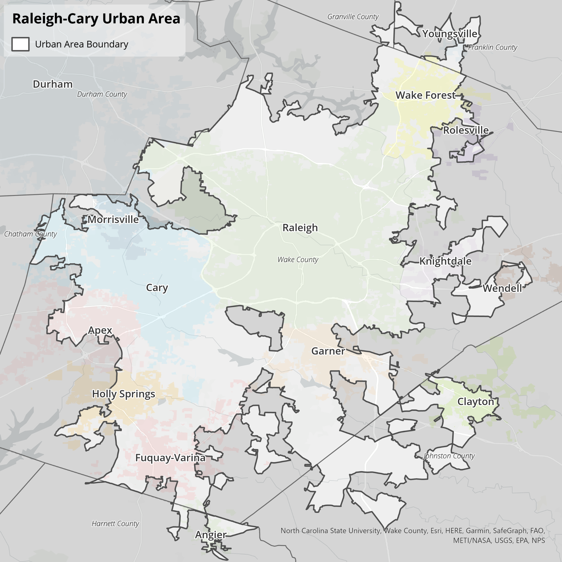
Figure 1: Raleigh-Cary Urban Area
Figure SEQ Figure \* ARABIC 1 Map of Raleigh-Cary Urbanized Area

Application Process
Completed applications (Parts I-III of the 5310 Funding Program Application) should be submitted online or provided to the GoRaleigh contact information below. Mailed applications should be delivered in an electronic format on a CD or flash drive. Mailed applications must be received at the address provided by the March 24 deadline. Applications submitted online are preferred.

Janice Copeland
4104 Poole Road
Raleigh, NC 27610
or
goraleigh@raleighnc.gov
Applications can be completed either as a Microsoft Word Document or a scanned PDF.

Application Submission
The 5310 Call for Projects and project selection will adhere to the following timeline:

2023 Application and Project Selection Schedule
February 27 First day to submit applications for 5310 funds
March 7 Virtual grant application workshop
March 10 Recorded grant workshop available on GoRaleigh’s website for application guidance
March 24 Last day to submit application for 5310 funds
April - May Third party application review
June Applicants notified of results
Upon completion of the selection process, GoRaleigh will coordinate with the project applicant to submit the necessary FTA documentation. Please see Appendix A – Documentation Required by FTA and Appendix B – Financial Management for requirements and example documentation needed from subrecipients who receive a Section 5310 grant award. Appendix C provides FTA references for topics related to questions from previous grant cycles.

Project Evaluation Criteria
FTA allows but does not require the use of selection criteria for awarding 5310 funding. Selection criteria were developed to guide application review and project selection. The following criteria were developed and are consistent with GoRaleigh’s past Job Access and Reverse Commute Program (JARC)/New Freedom Program Management Plan (2008), Wake County’s Coordinated Public Transit - Human Services Transportation Plan (2022), FTA’s 5310 guidance and review of peer agency Program Management Plans. The criteria align closely with the ‘Part II – Project Narrative’ section of the application.
Basic Screening Criteria
Applications will be evaluated to verify that the project meets the following basic screening criteria before the full scored evaluation:
- Is the project of a type that meets the basic goals of the Section 5310 program, i.e. it has a primary focus of serving seniors and individuals with disabilities?
- Is the project application complete, including attachments providing the budget and certified local match sources?
- Does the project serve trips that have an origin and/or destination within the Raleigh-Cary urbanized area?
If the answer to any of the basic screening criteria is “no”, the project is ineligible for funding and will not be scored.
- Project Needs (20 points)
Project applications should clearly state the need for the project and demonstrate how the project is consistent with the objectives of the Section 5310 grant program. The project application should indicate how the project will enhance transportation for the urbanized area’s elderly and disabled populations. The connection between the project and the Coordinated Public Transit - Human Services Transportation Plan should be clearly described in the application.
- Project Planning and Implementation (20 points)
For all projects, applicants must provide a well-defined service operations plan and/or capital procurement plan and describe the implementation steps and timelines for carrying out the plan. The applicant’s plan should include coordination, eligibility determination, marketing and service delivery details.
- Project Budget and Grants Management (15 points)
Applicants must submit a complete project budget, indicating anticipated project expenditures and revenues, including documentation of matching funds. The application should address long-term efforts and identify potential funding sources for sustaining the service beyond the grant period.
- Program Effectiveness and Evaluation (20 points)
The project will be scored based on the applicant’s identification of clear, measurable outcome-based performance measures, including customer satisfaction, to track the effectiveness of the service. The applicant should monitor and evaluate the service throughout the period of performance.
- Organizational Preparedness and Technical Capacity (25 points)
Projects should be a good fit in the applicant’s organization, meaning they should align with the organization’s mission and expertise. The applicant must demonstrate that it has staff with the technical experience to manage or operate a transportation service, such as correct levels of insurance for operations. In addition, the applicant must show that they are prepared to monitor and provide safe services. The applicant must demonstrate the capacity for financial oversight and strong internal controls.

Scoring Criteria
Project Evaluation Criteria | Possible Points
1. Project Needs | 20
Does the project support the 5310 grant program’s objectives? | 0 or 5
To what degree will the project increase or enhance the availability of transportation for the elderly and disabled populations in and around the Raleigh-Cary Urbanized Area‘s? | 0 – 5
How well does the project address needs identified in the Coordinated Public Transit - Human Services Transportation Plan? | 0 – 5
Does the project provide a service that otherwise would not be available? | 0 or 5
2. Project Planning and Implementation | 20
To what degree does the project include coordination and/or partnerships with transportation providers or other relevant stakeholders? | 0 – 5
Is the project timeline realistic? | 0 or 5
To what extent does the applicant include plans to market to the target group and promote public awareness of their project? | 0 – 5
Is there evidence the applicant has done all the necessary planning and is ready to begin the project upon being funded? | 0 – 5
3. Project Budget | 15
Does the submitted budget clearly identify anticipated project expenditures and revenues? | 0 or 5
Does the documentation demonstrate the matching funds are identified and available? | 0 or 5
How well does the agency demonstrate continued commitment to the life of the project beyond the availability of the requested grant resources? | 0 – 5
4. Program Effectiveness and Evaluation | 20
How well does the application describe collecting data and/or documenting the delivery and utilization of services? | 0 – 10
Does the applicant propose monitoring measurable indicators of success? | 0 – 10
5. Organizational Preparedness | 25
How closely does the proposed project align with the organization’s mission and objectives? | 0 – 5
How experienced is the applicant staff in managing transportation projects and/or operating passenger transportation? | 0 – 5
How experienced is the applicant with financial responsibilities such as quarterly reporting, annual audits, and/or other forms of financial reporting? | 0 – 10
If the applicant has previously been awarded a Section 5310 grant by GoRaleigh, does its documented past performance indicate that it may struggle to successfully manage the project and/or operate passenger transportation? Note: This question allows points gained for experience to be reduced based on previous performance. | -5 – 0
Does the applicant describe activities such as: training, vehicle maintenance, inspection, or monitoring to manage risk and to provide safe services? | 0 – 5
Total Score | 0 – 100

5310 Funding Program Application
Please complete Parts I-III of the 5310 Funding Program Application. Return the completed application to GoRaleigh as noted in the Application Process section.

Part I – Funding Request

Applicant Information
Organization Name: ____________________________________________________________________
Contact Person: _______________________________________________________________________
Address: _____________________________________________________________________________
City, State, Zip: ________________________________________________________________________
Telephone: _____________________________ Fax: _______________________________________
Email: _________________________________ Website: ___________________________________
Project Description
Title: ________________________________________________________________________________
Brief Description: _____________________________________________________________________________________
_____________________________________________________________________________________
_____________________________________________________________________________________
Project Type(s) –Select one: ○ Traditional ○ Other ○ Both
Project Funding Type(s) – Select all that apply: ◻ Capital ◻ Operating ◻ Vehicles Fulfilling ADA
Service days/hours (if applicable): _________________________________________________________
Estimated Cost per One-Way Trip (if applicable): _____________________________________________
Estimated Daily Riders per Weekday/Weekend (if applicable): __________________________________

Copies of submitted applications may be requested by submitting a Public Records Request to the City of Raleigh.
Translation assistance is available through the City’s Language Line Service. GoRaleigh staff will arrange for translations or interpretation services as needed in support of applicants with Limited English Proficiency.

Part II – Project Narrative
Please complete the Project Narrative questions below for your application. These questions closely align with the Project Selection Criteria included in the 5310 Program Management Plan and 5310 Application Package.

1. Expanded Project Description
a. Please use this space to expand on your project description beyond the brief description provided in Part I of the application if needed.

2. Project Needs
a. How is the proposed project consistent with eligible 5310 program activities and objectives of the 5310 funding program?

b. Describe how the project will increase or enhance the availability of transportation for the elderly and disabled populations in the Raleigh-Cary Urban Area.

c. What need(s) does the project address in the Coordinated Public Transit - Human Services Transportation Plan? Please provide the page number(s) in the Coordinated Public Transit - Human Services Transportation Plan.

d. Does the project provide a service or investment that otherwise would not be available? If so, please explain.

3. Project Planning and Implementation
a. Describe how the proposed project might coordinate or link with other transportation providers or transportation stakeholders.

b. Describe the project timeline and project lifespan.

c. Please note how you plan to market your proposed project. If it is an existing service, note how your service is currently marketed.

d. When could your project begin upon receiving funding? Describe the process your organization would take to implement the project.

4. Project Budget
a. In addition to filling out the Proposed Project Budget, note any plans for continued investment and/or maintenance for the proposed project after the 5310 funds are spent. Describe any other funds available currently or for future investments in this project.
b. Is your organization a government/public agency?
c. (IF YES TO ABOVE SKIP THE FOLLOWING QUESTION) Subrecipients may account for indirect costs in several ways.
- De minimis indirect cost rate is used when an applicant intends to claim reimbursement of indirect costs and has never negotiated an indirect cost rate. The de minimis indirect cost rate is equal to 10% of Modified Total Direct Costs (MTDC). The MTDC Worksheet provided in Part IV of the application packet is used to document Modified Total Direct Costs and determine the amount of allowable indirect costs.
- Approved indirect cost rate, indirect cost plan, or cost allocation plan. Applicants may have an established indirect cost rate approved by a federal agency based on one of the methods below. Applicants using approved rates must attach documentation of their approved indirect cost rate, indirect cost plan, or cost allocation plan.
  - A simplified allocation method expresses indirect costs as a percentage of the base cost. This is used when an organization’s major functions benefit from its indirect costs to approximately the same degree.
  - A multiple allocation base method requires an indirect cost plan or cost allocation plan. This method is used when an organization’s indirect costs benefit its major functions in varying degrees.
  - Special indirect cost rates are determined in the cost allocation plan or indirect cost plan. They are used when there are factors that substantially affect the indirect costs applicable to a particular segment of work (e.g. some work generates a significantly different level of indirect costs, or some indirect costs are only associated with a certain type of work.
- Direct allocation method (only applies to non-profit organizations). In this method, the applicant does not claim indirect expenses. This method is only applicable to nonprofits and generally used by small entities with relatively few indirect costs. In this method, all costs are treated as direct costs, except general administration and general expenses, which are prorated among the direct costs and reported as a portion of the direct costs based on reasonable criteria supported by current data. Generally, an acceptable base used to calculate indirect cost is percentage of actual time spent working on the grant. A request to use a different base is subject to approval.
- No reimbursement for indirect costs. An applicant may elect not to claim reimbursement for indirect costs under the Section 5310 grant program.
Which of the following methods does your organization use to account for indirect expenses (only one option will apply)?
- Our organization will apply a de minimis indirect cost rate. Attach the MTDC Worksheet provided in Part IV of the application packet.
- Our organization has an approved indirect cost rate, indirect cost plan, or cost allocation plan. Attach documentation of your approved indirect cost rate, indirect cost plan, or cost allocation plan
- Our organization reports all costs using the direct allocation method (applies only to non-profits). Note that additional documentation may be requested to support the applied rates.
- Our organization does not claim reimbursement for indirect costs.

5. Program Effectiveness and Evaluation
a. How does your organization plan to collect information to monitor quality control and customer satisfaction related to implementing the proposed project? Include in your description any measurable indicators you propose to use.

6. Organizational Preparedness
a. Describe how your proposed project aligns with the overarching mission of your organization.

b. Describe the staffing plan for this project. Who would be the primary staff person responsible for managing the grant? What other staff would be involved? Describe any relevant past experience these staff members have in working on the type of project proposed.

c. Please note any experience your organization has with financial reporting such as quarterly reports, annual audits and/or other forms of financial reporting.

d. Describe any training, maintenance, inspections and/or service monitoring you plan to do focused on managing risk and providing safe services.

Part III – Proposed Project Budget
A. Project Funding
Local matching funds are required for all application submittals. For projects requiring operating funds the required match is 50% from non-federal transportation funds. For capital projects the required match is 20%+ from non-federal transportation funds. Some potential capital match exceptions are noted in the FTA guidance and the GoRaleigh 5310 Program Management Plan. An example budget is shown below. Applicants should tailor project items as appropriate but submitted budgets should resemble this template.
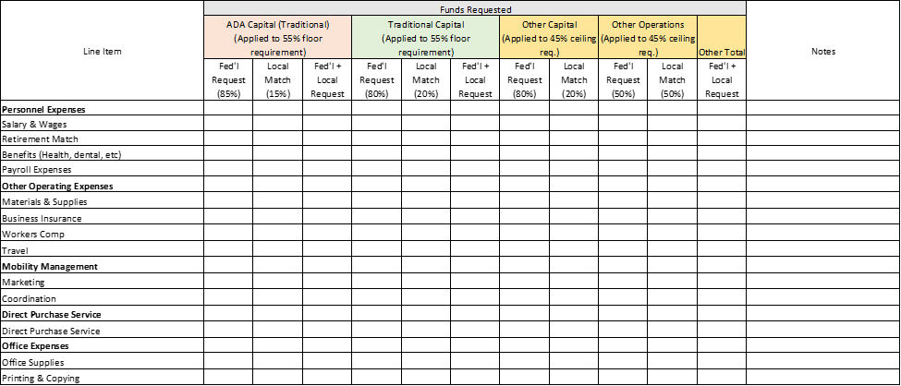
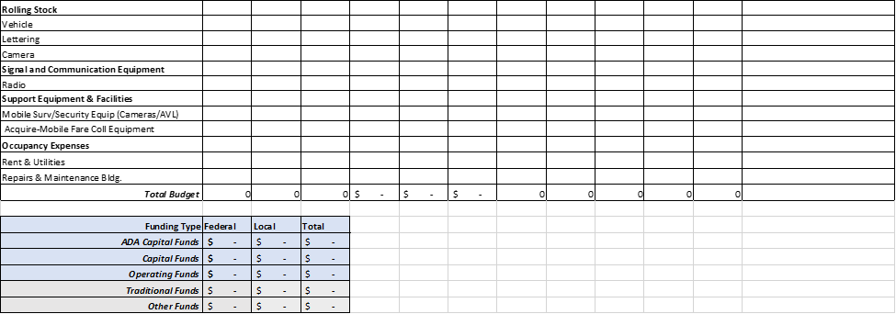
*Modify as needed if the applicant is seeking a 90% Federal, 10% local match funding split for vehicle related equipment and facilities.
Note: The applicant must demonstrate a commitment to provide local funds and provide appropriate documentation. Documentation may be in the form of a letter or other supporting documentation noting where funds will be drawn from.
Prior to any applications for a request to receive and use federal funds, the project needs to demonstrate that it meets all local, state and FTA requirements and that it is eligible to receive federal funds. Any match funding source outside the standards established by FTA must receive written approval from FTA to be used. Match funding should adhere to the following:
- Must be from an eligible funding source under FTA guidelines;
- Must be available at the time of the grant award;
- Match funding must be spent to qualify as a match;
- No federal funds may be drawn without authorization and availability of a sufficient match funding source;
- Subrecipients must certify the use of local match with the submission of each invoice;
- Subrecipients are required to provide quarterly reports that account for the use of local funds as match.
If needed, applicants should include an explanation to clarify a line item so that the request is easily understood. Some items that required further explanation:
  - Requests for personnel: provide title, number of hours for section 5310 project tasks, and wage rate
  - If a request is made for an item that is used for multiple project/organizational purposes, so that it is not used exclusively for Section 5310 project tasks, denote what percentage (1-100%) of the requested funds will be directly associated with carrying out Section 5310 program tasks. Also, denote if the dollar value of the fund request is for the full cost of the requested line item or the prorated cost of the line item (the proportion of the fund request solely associated with Section 5310 project costs).
  - Clustered line items: items such as “supplies,” “materials,” etc. need to be individually clarified so that it is readily apparent what the items requested are.

B. Local Match Documentation
Applicants must demonstrate a commitment to provide local funds and provide appropriate documentation. Documentation may be in the form of a letter or other supporting documentation noting where funds will be drawn from.
Match documentation should be submitted with this package with the following naming convention [OrganizationName]_Match2023.
Select the option that verifies whether a local funds match document has been submitted with this application.
○ Yes, submitted
○ No, not submitted

C. Eligible Projects Table
Traditional Projects | Nontraditional Projects
Funds can be applied to:  - Rolling stock/vehicle procurement, rehabilitation, or maintenance (buses and vans)  - Equipment (wheelchair lifts, ramps, and securement devices)  - Transit-related Information Technology  - Passenger facilities and amenities  - Mobility management and coordination programs  - Acquisition of transportation services under a contract, lease, or other arrangement. All capital and operating costs associated with contracted service are eligible capital expenses. | Funds can be applied to:  - Projects that seek to reduce barriers to transportation services and expand mobility options (travel training, volunteer driver programs)  - Exceed ADA requirements (enhanced paratransit services  - Improve access to fixed route service (sidewalks, curb cuts, wayfinding, technology, travel training etc.)  - Voucher, volunteer driver or taxi programs  - Incremental cost of providing same day service or door-to-door service
An itemized budget should be submitted with this package with the following naming convention [OrganizationName]_Budget2023.

Select the option that verifies whether an itemized budget has been submitted with this application.
○ Yes, submitted
○ No, not submitted
D. Lease Certification
If an applicant is requesting funding for an item that requires a lease, documentation is required to verify that the lease of equipment is more cost effective than purchase. Note that when lease of equipment or facilities is treated as a capital expense, the recipient must establish criteria for determining cost effectiveness in accordance with FTA regulations, “Capital Leases,” 49 CFR part 639 and OMB Circular A–94, which provides the necessary discount factors and formulas to be applied.
Please submit a separate file ([OrganizationName_Lease2023]) that demonstrates the lease of equipment is more cost-effective than purchase. The documentation should provide a comparison of the total costs of equipment purchased compared to the total cost of equipment leased over the applicants designated time-period of use.
If requesting funding for equipment leases, select the option that verifies whether financial documentation has been provided to demonstrate the lease of equipment is more cost-effective than purchase.
○ Yes, submitted ○ No, not submitted

Part IV - Modified Total Direct Cost (MTDC) Worksheet
Applicants submitting a de minimis indirect cost rate must provide documentation for their Modified Total Direct Cost. Please complete the worksheet on the following page and include it as part of your application.

Modified Total Direct Cost (MTDC) Worksheet

If the applicant does not have a current negotiated federal indirect rate, the applicant may apply a de minimis rate of up to ten percent of its modified total direct costs (MTDC). If chosen, the applicant must use this method and rate consistently for all Federal awards. The applicant must consistently charge all costs as either direct or indirect costs.

CFR § 200.68 states that Modified Total Direct Cost (MTDC) “means all direct salaries and wages, applicable fringe benefits, materials and supplies, services, travel, and subawards and subcontracts up to the first $25,000 of each subaward or subcontract (regardless of the period of performance of the subawards and subcontracts under the award). MTDC excludes equipment, capital expenditures, charges for patient care, rental costs, tuition remission, scholarships and fellowships, participant support costs and the portion of each subaward and subcontract in excess of $25,000. Other items may only be excluded when necessary to avoid a serious inequity in the distribution of indirect costs, and with the approval of the cognizant agency for indirect costs.”

Please complete the table below to calculate your organization’s MTDC and de minimis indirect costs.

Modified Total Direct Costs Worksheet
Total allowable salaries and wages
Total associated fringe benefits
Total materials and supplies costs
Total services costs
Total travel costs
Total Subawards/subcontracts up to $25,000
Total Modified Direct Cost (MTDC) Base of Grant
Proposed de minimis rate. Percentage cannot exceed 10%.
MTDC Base x % = allowable de minimis indirect cost amount.

Appendix A – Documentation Required

Required Documents
These items will be required to be submitted if a project is awarded.
Reference Documents – References for Grant Requirements (please note that this list is not exhaustive. The subrecipient is responsible for adhering to all federal, state and local grant requirements).
- Uniform Guidance 2 CFR 200
- Office of Management and Budget (OMB) - 2 CFR part 200
- Federal Transit Administration Master Agreement
- Procurement (FTA Circular 4220.1F)
Please provide the following documents, if applicable to your agency. For each document, please provide the most recent completed, unless otherwise stated. For those items where you do not have an official written policy or manual, please provide a brief narrative describing your current process.
Annual Audited Financial Statements (if new subrecipient, provide copies of last 3 fiscal years)
Form 990 (most recently filed)
State Reports (State Reviews, State Maintenance)
Triennial Review Report
Other Reports (any federal/state/audit reports not listed above)
Board of Directors – List of members and Bios
Federal Tax Liability and Recent Felony Convictions Certification
Procurement Manual
Written Standards of Conduct (including conflict of interest policy)
Agency Organizational Chart
Organizational Chart for division(s) that manage financial and programmatic aspects of grant
Equal Employment Opportunity Policy
Title VI Notice & Program
Disadvantaged Business Enterprise (applicable if recipient award- third party contracts that exceed $250,000 in a federal fiscal year)
Americans with Disability Act Policy
Drug & Alcohol Policy and Testing – Drug-free Workplace
Transit Vehicle Manufacturer (TVM) Certification/Reporting
Access to Services for Persons with Limited English Proficiency Policy
Asset Management Policy
FTA Funded Asset Listing – Inventory, Depreciation, Maintenance
Seat Belt Use Policy
Distracted Driver’s Policy
Safety and Security Procedures Process for safeguarding equipment and valuable assets
Protection of Sensitive Information Policy – Process for safeguarding eligibility documentation for program participants and related personally identifiable information (PII)
Indirect Cost Plan (please note that subaward is dependent upon approval of the indirect cost plan by the FTA)

Appendix B – Financial Management
Financial Expectations
Reimbursement packet with all required documentation (including support for all expenses) must be submitted to GoRaleigh no later than 30 days after quarter end.
Payments will be processed within 30-45 days after reimbursement requests are received. If there are errors in the reimbursement packet or additional documentation is needed, additional time may be needed to process the reimbursement request.
Procurements – When using federal funds for securing goods and/or services, all procurement activities must be compliant with Federal laws and regulations. Refer to FTA Circular 4220.1F for guidance.
Eligible Cost Requirements - refer to Reference Document list in application materials
- Consistent with description and scope of each project, the award budget, federal grant requirements, the underlying agreement and any related amendments
- Costs are necessary to carry out the award
- Costs are reasonable for the property or services for use in the project
- The actual net costs, which consists of the price paid minus any reduction of costs incurred, such as refunds, rebates, or other items of value, but excluding program income
- Costs incurred within period of performance beginning and end dates
- Costs are satisfactorily documented
- Costs are consistent with federally approved accounting principles and procedures
- Costs are consistent with US Department of Transportation Common Rules and other federal law, regulations, requirements, and guidance
Ineligible Costs -
- Costs outside of the performance period beginning and end dates
- Cost not included in award budget
- Costs for property or services with third party agreement lacking FTA approval
- Any ordinary governmental or operating cost not applicable to the award as prohibited by 49 U.S.C. § 5323(h)(1);
- A profit or fee for services provided by the recipient (subrecipient) in implementing the award
- Costs that are ineligible for FTA participation as provided in applicable federal law, regulation, or guidance
Required Documentation/Requirements for Reimbursement
- Letter of Invoice – This document provides the reimbursement amount requested and certifies the total 5310 eligible expenses for the period. Required with all reimbursement requests. (Exhibit A)
- Program Narrative – Program narrative that describes services performed during the reimbursement period. Required with all reimbursement requests. (Exhibit B)
- Subrecipient is required to submit the excel reimbursement template with every reimbursement request. (Exhibit C)
- Payroll - If requesting direct or indirect reimbursement for salaries and payroll related items, the following documentation is required. It can be submitted in electronic format (preferred) or hard copy.
  - Time Sheets & Payroll Reports – Time sheets and payroll reports should identify actual time spent working on Section 5310 grant activities, instead of estimated time on the grant. If subrecipient allocates time to multiple grants/resources, time sheets detailing time spent in each area are required.
  - Reconciliation of payroll report to excel reimbursement template
  - Reconciliation of payroll to General Ledger report
- Program Expenditures – Detailed documentation for program expenditures is required. Documentation should be easily labeled and may include the following:
  - Invoices
  - Receipts
  - Vouchers
  - Approvals
  - Vehicles – If purchasing vehicles, backup documentation should include pre/post audit certifications, insurance, title, and inventory/asset reports identifying the equipment
  - Buy America certification, if applicable
- Excel versions of documents should be submitted to show any calculations/formulas, when applicable.
- Subrecipient must reconcile program expenditures to excel reimbursement template – Each support page must be marked with a letter (A, B, C…) and the letter will tie back to the second column in the Excel reimbursement template. Subrecipient must coordinate with Raleigh’s program manager if they would like to request to use a different method of labeling supporting documentation.
- Rounding requirements – Amounts should be rounded at final calculation. Do not round components of the calculation. Show percentages at three decimal places and dollar amounts at two decimal places. If submitting a PDF document which includes calculations, then an Excel version must also be provided.
- Indirect Cost Plan – If subrecipient has an approved indirect cost plan for federal grants, GoRaleigh must obtain FTA approval of the indirect cost plan before any reimbursements are processed. Indirect costs will not be reimbursed without prior FTA approval. 2 CFR 200.403 and 2 CFR 200.414
- Indirect costs – Indirect costs can be charged by one of three methods – an approved Indirect Cost Rate Plan, the De Minimus rate, or a percentage based on time spent on the grant with proper payroll documentation. Expenses reimbursed as part of the indirect costs plan should not also be requested for reimbursement as a direct expense.
- In-Kind Services / Donated services / Volunteer services (may be used for non-cash match) Volunteer services must be accounted for at a reasonable rate based on what other employees within the agency are paid and general market comparison for similar duties.
- As part of GoRaleigh’s monitoring activities, agencies will be asked to provide listings of program participants and their related eligibility documentation (seniors 65 and over and/or persons with disability). Provide updates as new program participants are added to the program. Agencies are expected to retain documentation and safeguard for onsite monitoring.
- Mileage – Backup should include a description identifying trip purpose along with mileage supported by Google maps, Mapquest, etc.
- Record Retention – Records should be retained from authorized performance period until three years after the recipient has submitted its last or final expenditure report and other pending matters are closed. Formats or records may be electronic, email, paper and other formats as approved by FTA. Records must be accessible for review and stored separate from other records not related to the award to the extent feasible.

Exhibit A – Letter of Invoice

PO:

Invoice #:

Date:

Janice Copeland
City of Raleigh – Transit Section
P. O. Box 590
Raleigh, NC 27601

SUBJECT: LETTER OF INVOICE
Quarterly Report
October 1, 2019 through December 31, 2019
FFY 2019-2020

Dear Ms. Copeland:

This letter invoice is to request reimbursement in the amount of $_________, which is XX% of $_________ the total amount expended this month.

Sincerely,

(Name)
(Title)

Total Amount Eligible for Reimbursement $ ________ (Total Amt Eligible)
Less Previous Reimbursements $ _________(Total amt previous reimbs)
Net Amount Payable this Invoice $ _________(Amt this invoice)
=============================================================
CERTIFICATION

This is to certify that as of __(Qtr End)_____, costs in the amount of $ ________ _have been incurred ____(Agency Name)______ in the FY 2019-2020 approved budget.

_______________________________
Finance Director

Exhibit B – Program Narrative
PO Number: ___________

DATE OF REPORT:
REPORT NUMBER:  1st Quarter  2nd Quarter  3rd Quarter  4th Quarter

QUARTERLY NARRATIVE PROGRESS REPORT

FOR QUARTER: October 1, 2019 TO December 31, 2019

RETURN PROGRESS REPORT TO:
Janice Copeland
City of Raleigh – Transit Section
P. O. Box 590
Raleigh, NC 27601

1. TITLE OF PROJECT:

- AGENCY:

- NAME, TITLE, AND PHONE NUMBER OF PERSON COMPLETING REPORT (signature required at end of report):

4. NARRATIVE OF WORK COMPLETED DURING THIS QUARTER
(attach additional sheets if needed):

____________________________
Signature

FOR OFFICE USE ONLY: Date Report Received: ____________

Report Received by: _______________________ COMMENTS: ___________________________________

________________________________________________________________________________________

Exhibit C – Reimbursement Template

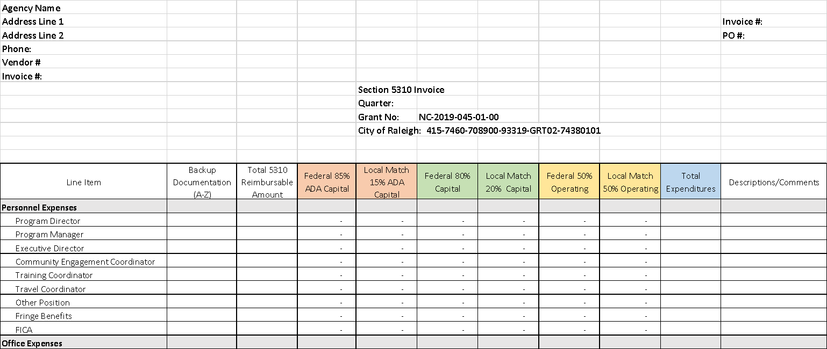

Appendix C – FTA Reference Guide for select topics
This appendix lists topics from previous grant application cycles that many applicants had questions about.
Note that procurement requirements outlined in 2 CFR 200 may also apply or supersede requirements identified in the FTA Circular.

Leasing Vehicles Acquired with Section 5310 Funds
See excerpt from Chapter VI-6 of FTA’s 5310 Program Circular below:
Vehicles acquired under the Section 5310 program may be leased to other entities such as local governmental authorities or agencies, other private nonprofit agencies, or private for-profit operators. Under such a lease, the lessee operates the vehicles on behalf of the Section 5310 subrecipient and provides transportation to the subrecipient’s clientele as described in the grant application.
The lease between the Section 5310 subrecipient and the lessee contains the terms and conditions that must be met in providing transportation service to seniors and people with disabilities. Because the purpose of the Section 5310 grant is to provide transportation service to seniors and people with disabilities, other uses of the vehicle are permitted only as long as such uses do not interfere with service to seniors and people with disabilities.
The state or designated recipient, being responsible for ensuring that the terms and conditions of the original grant with FTA are met, must agree, in writing, to each lease between the subrecipient and the lessee. Such an agreement should specify that the leased vehicle shall be used to provide transportation service to seniors and people with disabilities, that the vehicle may be used for incidental purposes only after the needs of these individuals have been met, and that the subrecipient, state, or designated recipient must retain title to the vehicle.
Recipients may lease any of their assets to others on an incidental basis so long as the lease agreement holds the lessee responsible for compliance with all of the requirements the recipient itself is responsible for. Thus, the lessee must adhere to applicable and relevant terms and conditions of FTA’s master agreement in the maintenance and use of the asset. For example, a recipient may not lease its revenue vehicles to a private company to conduct charter operations except to the extent the recipient itself would be able to conduct charter operations.
A recipient may lease its assets to a private entity to operate in public transit service so long as the entity has been selected through a competitive process and so long as the lease agreement obliges the lessee to adhere to all of the applicable and relevant requirements of the FTA master agreement. A finite lease term should be established as well as a clear price and scope of work.
Meal Delivery Services
See excerpt from Chapter VI-5 of FTA’s 5310 Program Circular below:
5310 Programs can partner with meal delivery service programs. Transit service providers…may coordinate and assist in providing meal delivery services on a regular basis if the meal delivery services do not conflict with the provision of transit services or result in a reduction of service to transit passengers.

Software Procurement
Procurement requirements from FTA’s 5310 program are described below.
See excerpt from Chapter VI-7 of FTA’s 5310 Program Circular below:
PROCUREMENT.
a. General. When procuring property, supplies, equipment, or services with funds from an FTA grant, designated recipients that are not states and their subrecipients must comply with FTA procurement requirements at 49 CFR part 18 and guidance contained in the current FTA Circular 4220.1. States will follow the same policies and procedures used for procurements from nonfederal funds to the extent permitted by federal statutes and regulations. While the federal threshold for small purchases is currently $100,000, the state may set a lower threshold for itself and its subrecipients. All governmental authority subrecipients may follow state procurement procedures. However, because of differences between 49 CFR part 18 and 49 CFR part 19, FTA third party contracting requirements are fewer for states and subrecipients that are local or tribal governments than for subrecipients that are private nonprofit organizations. For the sake of consistency, the state may choose to use the more detailed FTA requirements included in the current FTA Circular 4220.1 for all subrecipients as part of its state procurement procedures.
In some cases, a state may choose to grant Section 5310 assistance to a subrecipient through an intermediary subrecipient. For example, for public policy reasons, the state might pass funds to a nonprofit organization through a local governmental authority. The arrangement between the first tier and second tier subrecipient is not a third party contract if the ultimate subrecipient would otherwise be eligible under Section 5310 to receive funds directly from the state and the ultimate subrecipient intends to use those funds to pursue its own transit project to meet the needs of seniors and people with disabilities.
Each FTA recipient seeking federal assistance to acquire property or services in support of its proposed project shall certify to FTA, in accordance with 49 CFR 18.36, that its procurements and procurement system will comply with all applicable third party procurement provisions of federal laws, regulations, and directives, except to the extent FTA has expressly approved otherwise in writing. Any applicant that fails to provide this certification may be determined ineligible for award of federal assistance if FTA determines that its procurement practices and procurement system are incapable of compliance with federal laws, regulations, and directives governing procurements financed with FTA assistance.

Printers / Copiers
Printers/ copiers are considered administrative cost which is an allowable up to 10% of allocated FTA Funds.
See excerpt from Chapter III-12 of FTA’s 5310 Program Circular below:
Allowable administrative costs may include, but are not limited to, general administrative and overhead costs, staff salaries, office supplies, and development of specifications for vehicles and equipment. Guidance on eligible costs is in Office of Management and Budget (OMB) Circular A–87 (codified at 2 CFR part 225). The program administration budget line item may also include technical assistance and planning activities, including allocations to subrecipients to support the local coordinated planning process. Any general overhead costs must be supported by an indirect cost allocation plan that has been approved by FTA or another cognizant federal agency.

Equipment that is Shared between Section 5310 and other Uses
See excerpt from Chapter VI-5 of FTA’s 5310 Program Circular below:
FTA encourages maximum use of vehicles funded under the Section 5310 program. Consistent with the requirements of 49 CFR parts 18 and 19, vehicles are to be used first for program-related needs for which a Section 5310 grant is made and then to meet other federal programs or project needs, providing these uses do not interfere with the project activities originally funded. If the vehicle is no longer needed for the original program or project, the vehicle may be used in other activities currently or previously supported by a federal agency. Vehicles may be used:
a. For Section 5310 Project and Program Purposes. Recipients should consider how best to meet the needs of all seniors and people with disabilities in a particular community in the recipient’s project selection process. The program must provide for maximum feasible coordination with transportation services assisted by other federal sources. Subrecipients should be encouraged to the extent feasible to also provide service to seniors and people with disabilities not affiliated with their agency, as well as to the general public, on an incidental basis if such service does not interfere with transportation services for seniors and people with disabilities. In some situations it may be appropriate to provide Section 5310 assistance to an agency to provide transportation exclusively to its own clients, but even in situations in which it is not feasible for the agency to provide services to those in the community beyond its own clients, that agency must, when practicable, make the vehicle itself available to provide transportation service to other seniors and people with disabilities at times the agency is not using the vehicle for grant-related purposes. The recipient shall use the vehicle in the project or program for which it was acquired as long as needed, even if the project does not continue to receive federal funding.
b. For Other Federal Programs or Project Purposes. During the period the vehicle is used to serve the project or program needs for which it was acquired, the recipient or subrecipient shall make it available for use on other projects or programs, as long as such other use does not interfere with the service for which the vehicle was originally acquired. First preference for such other use will be given to other projects or programs sponsored by FTA, and second preference will be given to projects or programs sponsored by other federal agencies. Finally, vehicles may be used by non-federally funded providers, first to meet the needs of seniors and people with disabilities, and then to serve the transportation needs of the general public on an incidental basis.
c. When No Longer Needed for Original Project or Program Purposes. If the original recipient or subrecipient no longer needs the vehicle for the purposes for which it was acquired, the state or designated recipient may choose to keep the vehicle in use for Section 5310 program purposes by transferring the vehicle to another designated recipient or subrecipient. The transfer may be shown in the POP for any active grant. It does not have to be in the grant under which the vehicle was originally funded. Once the vehicle is no longer needed for Section 5310 program purposes, the vehicle may be used first in connection with other FTA-sponsored activities, and then for activities sponsored by other federal agencies.

Mobility Management Traditional (Capital) vs. Nontraditional (Operational)
The 5310 Circular specifically references the following activities as eligible:
Mobility Management appears as an eligible expense under both the “Traditional” and “Other” 5310 categories

Mobility Management is a practice that:
  - Captures mobility needs and develops solutions
  - Links and coordinates transportation resources
  - Connects resources to people for easy access
  - Mobility Management includes:
  - The promotion, enhancement, and facilitation of access to transportation services
  - Technology
  - One-stop information
  - Travel training
  - Coordination activities

Section 5310 is used to provide a range of mobility management services, including:
- Half-price taxi vouchers
- Washington Island Community Van, or ferry rides
- Shared-ride taxi program
- Volunteer driver programs
- Information and referral services
- Mobility manager on staff

Further information regarding eligible activities can be found on FTA Circular 9070.1G, Chapter III, Sections 13. – 15.

