2026 CALL FOR PROJECTS &
GRANT APPLICATION

FOR THE RALEIGH URBANIZED AREA TRANSPORTATION FOR ELDERLY PERSONS AND PERSONS WITH DISABILITIES FUNDING PROGRAM (SECTION 5310)

Contents
Introduction 3
Funding Availability 3
Project Eligibility 3
Eligible Applicants 5
Map of Urban Area 6
Application Process 7
Application Submission 7
Project Evaluation Criteria 9
Section 5310 Scoring Criteria 11
5310 Funding Program Application 12
Part I – Funding Request 12
Part II – Project Narrative 14
Part III – Proposed Project Budget 22
Part IV - Modified Total Direct Cost (MTDC) Worksheet 32
Appendix A – Documentation Required 33
Appendix B – Financial Management 35
Exhibit A – Letter of Invoice 38
Exhibit B – Program Narrative 40
Exhibit C – Reimbursement Template (downloadable file separately available) 42
Appendix C – Additional Detail on Eligible Projects from FTA Section 5310 Guidance 44
Traditional Capital Expenses 44
Other Expenses 46
Appendix D – FTA Reference Guide for Select Topics 50

Introduction

This application package is for the 2026 Call for Projects for the Federal Transit Administration (FTA) Transportation for Elderly Persons and Persons with Disabilities Funding Program (Section 5310) for the Raleigh Urban Area. This 5310 application package provides interested applicants with information on funding availability, project eligibility, the application timeline, the application process, and project evaluation criteria, among other items.
GoRaleigh (City of Raleigh) is the Designated Recipient for Section 5310 funds in the Raleigh Urban Area. As the Designated Recipient, GoRaleigh is responsible for developing a 5310 Program Management Plan and administering a Call for Projects for the available funding. Interested applicants should review the 5310 Program Management Plan and this application package to determine whether they are eligible to apply for and receive funding.

Funding Availability

Currently, there is $2,259,744 in total funding. Ten percent of the total awarded Section 5310 funds are allocated to program management by GoRaleigh, approximately 14 percent of funds are allocated to CAMPO for Mobility Management Coordination, and the remainder of Section 5310 funds are available for the Call for Projects. A minimum of 55 percent of allocated Section 5310 funds must be distributed to “traditional” capital expenses, and a maximum of 45 percent of allocated Section 5310 funds may be distributed to “other” eligible capital and operating expenses.
Note that all disbursements under the new program cycle are dependent upon a successfully executed grant agreement with the FTA.

Project Eligibility

Section 5310 funds are available for capital and operating expenses to support the provision of transportation services to address the specific needs of seniors (aged 65 and older) and persons with disabilities. Project elements and expenses are categorized under FTA guidance as traditional or other expenses. Although it also includes mobility management and coordination activities, traditional expenses are deemed “capital” expenses under FTA Guidance (FTA C 9070.1H). “Other” project elements can include capital or operating activities and expenses. Table 1 illustrates differences between these project activities and expense types, but it is not exhaustive; see more details in Appendix C – Additional Detail from FTA Guidance on Eligible Projects.
Table 1. Project Element or Expense Types by Section 5310 Category (Traditional or Other)
Traditional Capital Project Elements/Expenses  (at least 55% of grant funds awarded) | Other Project Elements/Expenses  (up to 45% of grant funds awarded)
- Rolling stock/vehicle procurement, rehabilitation, or maintenance (buses and vans)  - Equipment (wheelchair lifts, ramps, and securement devices)  - Transit-related Information Technology  - Passenger facilities and amenities  - Mobility management and coordination programs  - Acquisition of transportation services under a contract, lease, or other arrangement. All capital and operating costs associated with contracted service are eligible capital expenses | - Projects that seek to reduce barriers to transportation services and expand mobility options (travel training, volunteer driver programs)  - Exceed ADA requirements (enhanced paratransit services)  - Improve access to fixed route service (sidewalks, curb cuts, wayfinding, technology, travel training etc.)  - Voucher, volunteer driver or taxi programs  - Incremental cost of providing same day service or door-to-door service

Considerations for All Projects (both Traditional and Other)
- The proposed project must be designed especially to serve persons with disabilities and elderly persons. A proposed project that serves a customer base that only incidentally includes persons with disabilities or elderly persons and does not go further to meet the needs of persons with disabilities or elderly persons is not eligible for Section 5310 funding.
- All projects must serve trips that have an origin and/or destination within the Raleigh Urban Area to qualify for these Section 5310 Urban Area funds. Please find a map of the Raleigh Urban Area on Page 11, Figure 1.
- The proposed project must address a need identified in the Capital Area Metropolitan Planning Organization (CAMPO) Coordinated Public Transit - Human Services Transportation Plan for the region.

Considerations for Traditional Projects
- The GoRaleigh Section 5310 Program Management Plan restricts eligibility for vehicle (rolling stock) purchases to:
  - Organizations that are also direct recipients of FTA funds, as well as
  - Government entities and agencies that have historically received funds from FTA and compliance oversight from the North Carolina Department of Transportation (NCDOT).
- Capital activities (e.g., acquisition of rolling stock and related activities, acquisition of services, etc.) to support ADA complementary paratransit service may qualify toward the 55 percent requirement, so long as the service is provided by an eligible recipient or subrecipient and is included in the coordinated plan.
Note: Of the total funding that GoRaleigh awards to Section 5310 projects, at least 55 percent must go to Traditional Capital Project elements. If GoRaleigh receives project applications that collectively request too little Traditional Capital funding (less than 55 percent of available funding) and too much Section 5310 funding for other project elements (more than 45 percent of available funding), some of projects may have their other project elements partially or fully unfunded to reduce the total funding so until the Traditional Capital percentage reaches 55 percent.
For the above reason, applicants must carefully categorize expenses in their proposed project budgets as either traditional or other expenses. Applicants are encouraged to ask clarifying questions at the virtual workshop or office hours.

Eligible Applicants

Under the federal guidelines, eligible subrecipients for traditional capital Section 5310 projects include:
- Private nonprofit organizations, and
- State or local governmental authorities that:
  - Are approved by the State to coordinate services for seniors and persons with disabilities, or
  - Certify that there are no nonprofit organizations readily available in the area to provide the service.
Eligible subrecipients for other capital and operating Section 5310 projects include:
- Private nonprofit organizations,
- State or local governmental authorities, and
- Operators of public transportation, including private taxi companies and Transportation Network Companies that provide shared-ride, on-demand service to the general public.
To be eligible for funding from the 5310 program, proposed projects must be located within or have an origin or destination within the Raleigh Urban Area.

Map of Urban Area

Potential applicants must propose services that are either within the Raleigh Urban Area or provide connecting service to the Raleigh Urban Area as shown in Figure 1 below. Interested applicants not meeting that geographic requirement might qualify for NCDOT Section 5310 funding available for small urban and rural areas.
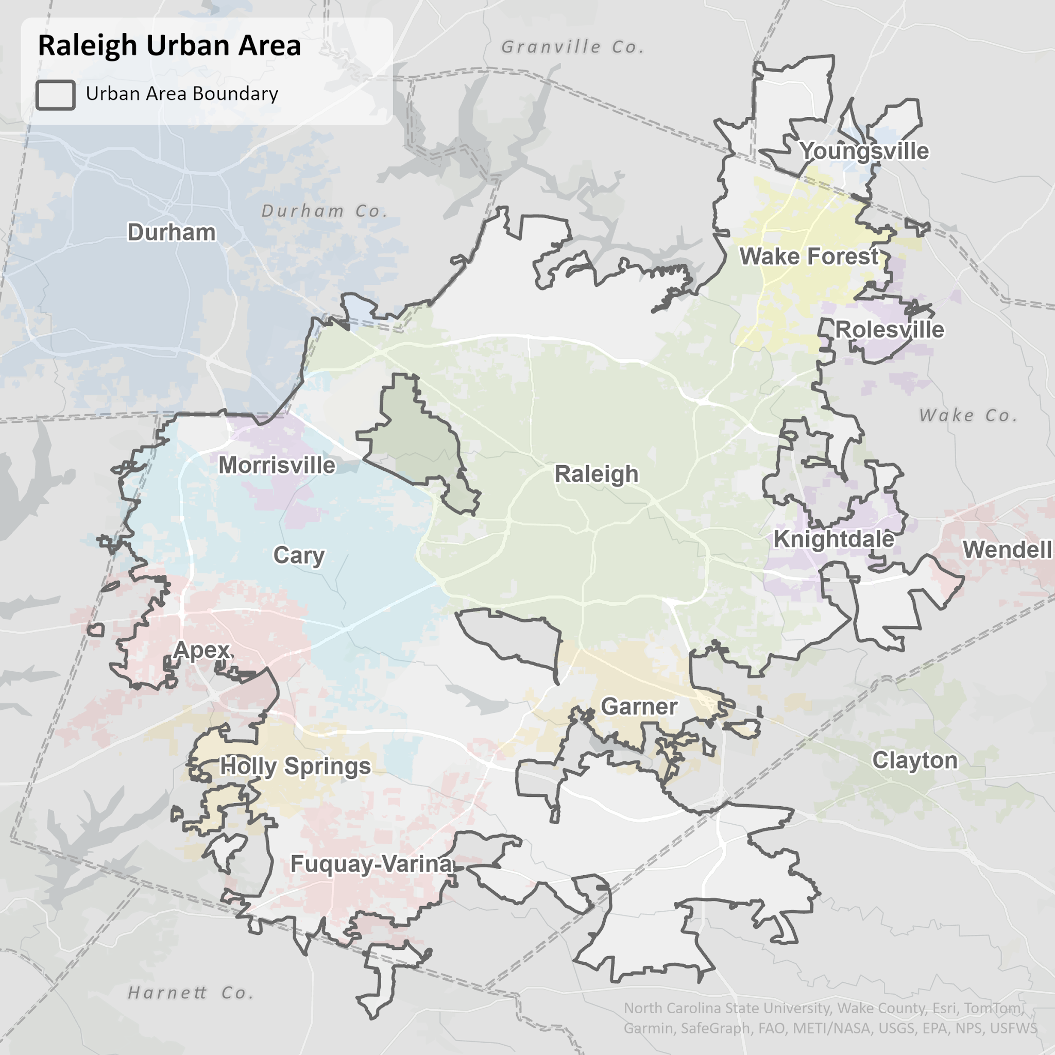
Figure 1: Raleigh Urban Area

Application Process

Completed applications (Parts I-III of the 5310 Funding Program Application) should be submitted online or provided to the GoRaleigh contact information below. Applications submitted online are preferred.
Tierra M. Hobley
goraleigh@raleighnc.gov
Applications can be completed either as a Microsoft Word Document or a scanned PDF.

Application Submission

The 5310 Call for Projects and project selection will adhere to the timeline shown in Table 2.
Table 2. GoRaleigh FTA Section 5310 Application Schedule
Date(s) | Item
August 10 | Grant application webinar
August 17 | First day to submit applications for Section 5310 funding  Grant webinar recording made available on GoRaleigh’s website for application guidance
August 18 through September 10 | Virtual office hours (scheduled twice weekly)
September 14 | Last day to submit application for Section 5310 funding
September 15 through October | Third-party review of applications
January 2027 | Applicants notified of results

Upon completion of the selection process, GoRaleigh will coordinate with the project applicant to submit the necessary FTA documentation. Please see Appendix A – Documentation Required by FTA and Appendix B – Financial Management for requirements and example documentation needed from subrecipients who receive a Section 5310 grant award. Appendix C provides additional detail on eligible project activities from FTA guidance. Appendix D provides FTA references for topics related to questions from previous grant cycles.

Project Evaluation Criteria

FTA allows but does not require the use of selection criteria for awarding 5310 funding. Selection criteria were developed to guide application review and project selection. The following criteria were developed and are consistent with GoRaleigh’s Program Management Plan (2026), past Job Access and Reverse Commute Program (JARC)/New Freedom Program Management Plan (2008), Wake County’s Coordinated Public Transit - Human Services Transportation Plan (2024), FTA’s 5310 guidance and review of peer agency Program Management Plans. The criteria align closely with the ‘Part II – Project Narrative’ section of the application.

Basic Screening Criteria
Applications will be evaluated to verify that the project meets the following basic screening criteria before the full scored evaluation:
- Is the project of a type that meets the basic goals of the Section 5310 program, i.e. it has a primary focus of serving seniors and individuals with disabilities?
- Is the project application complete, including attachments providing the budget and certified local match sources?
- Does the project serve trips that have an origin and/or destination within the Raleigh urbanized area?
If the answer to any of the basic screening criteria is “no”, the project is ineligible for funding and will not be scored.
Note: Applicants that have not previously received a GoRaleigh Section 5310 award will be subject to an organizational risk assessment prior to execution of a grant agreement. Successful completion of the risk assessment, including resolution of any identified deficiencies, is required before reimbursement of grant funds.

Scoring Rubric High-Level Elements
If a project passes the basic screening criteria, it is scored according to a rubric. The high-level elements of the rubric are described below, and the rubric itself is provided in the following section.
- Project Needs (20 points)
Project applications should clearly state the need for the project and demonstrate how the project is consistent with the objectives of the Section 5310 grant program. The project application should indicate how the project will enhance transportation for the urbanized area’s elderly and disabled populations. The connection between the project and the Coordinated Public Transit - Human Services Transportation Plan should be clearly described in the application.
- Project Planning and Implementation (20 points)
For all projects, applicants must provide a well-defined service operations plan and/or capital procurement plan and describe the implementation steps and timelines for carrying out the plan. The applicant’s plan should include coordination, eligibility determination, marketing and service delivery details.
- Project Budget and Grants Management (15 points)
Applicants must submit a complete project budget, indicating anticipated project expenditures and revenues, including documentation of matching funds. The application should address long-term efforts and identify potential funding sources for sustaining the service beyond the grant period.
- Program Effectiveness and Evaluation (20 points)
The project will be scored based on the applicant’s identification of clear, measurable outcome-based performance measures, including customer satisfaction, to track the effectiveness of the service. The applicant should monitor and evaluate the service throughout the period of performance.
- Organizational Preparedness and Technical Capacity (25 points)
Projects should be a good fit in the applicant’s organization, meaning they should align with the organization’s mission and expertise. The applicant must demonstrate that it has staff with the technical experience to manage or operate a transportation service, such as correct levels of insurance for operations. In addition, the applicant must show that they are prepared to monitor and provide safe services. The applicant must demonstrate adequate organizational, financial, and administrative capacity to successfully manage grant funds. This includes documented internal controls, financial oversight processes, procurement compliance, records retention practices, and readiness to comply with FTA monitoring requirements.

Section 5310 Scoring Criteria
Project Evaluation Criteria | Possible Points
1. Project Needs | 20
Does the project support the 5310 grant program’s objectives? | 0 or 5
To what degree will the project increase or enhance the availability of transportation for the elderly and disabled populations in and around the Raleigh Urbanized Area? | 0 – 5
How well does the project address needs identified in the Coordinated Public Transit - Human Services Transportation Plan? | 0 – 5
Does the project provide a service that otherwise would not be available? | 0 or 5
2. Project Planning and Implementation | 20
To what degree does the project include coordination and/or partnerships with transportation providers or other relevant stakeholders? | 0 – 5
Is the project timeline realistic? | 0 or 5
To what extent does the applicant include plans to market to the target group and promote public awareness of their project? | 0 – 5
Is there evidence the applicant has done all the necessary planning and is ready to begin the project upon being funded? | 0 – 5
3. Project Budget | 15
Does the submitted budget clearly identify anticipated project expenditures and revenues? | 0 or 5
Does the documentation demonstrate the matching funds are identified and available? | 0 or 5
How well does the agency demonstrate continued commitment to the life of the project beyond the availability of the requested grant resources? | 0 – 5
4. Program Effectiveness and Evaluation | 20
How well does the application describe collecting data and/or documenting the delivery and utilization of services? | 0 – 10
Does the applicant propose monitoring measurable indicators of success? | 0 – 5
Does the applicant describe how it will monitor compliance with grant requirements, maintain required documentation, and ensure project accountability throughout the award period? | 0 - 5
5. Organizational Preparedness | 25
How closely does the proposed project align with the organization’s mission and objectives? | 0 – 5
How experienced is the applicant staff in managing transportation projects and/or operating passenger transportation? | 0 – 5
How experienced is the applicant with financial responsibilities such as quarterly reporting, annual audits, and/or other forms of financial reporting? | 0 – 5
If the applicant has previously been awarded a Section 5310 grant by GoRaleigh, does its documented past performance indicate that it may struggle to successfully manage the project and/or operate passenger transportation? Note: This question allows points gained for experience to be reduced based on previous performance. | -5 – 0
Did the applicant attend the workshop? 5 points is awarded if the applicant attended the workshop and office hours. 3 points is awarded if the applicant attended the workshop only. | 0, 3, or 5
Does the applicant describe activities such as: training, vehicle maintenance, inspection, or monitoring to manage risk and to provide safe services? | 0 – 5
Total Score | 0 – 100

5310 Funding Program Application

Please complete Parts I-III of the 5310 Funding Program Application. Complete your application online or return the completed application to GoRaleigh as noted in the Application Process section.

Part I – Funding Request

Applicant Information
Organization Name: _________________________________________________________________
Contact Person: ____________________________________________________________________
Address: __________________________________________________________________________
City, State, Zip: _____________________________________________________________________
Telephone: _____________________________ Fax: ____________________________________
Email: _________________________________ Website: ________________________________
Project Description
Title: ______________________________________________________________________________
Brief Description: __________________________________________________________________________________
__________________________________________________________________________________
__________________________________________________________________________________
Project Type(s) –Select one: ○ Traditional ○ Other ○ Both
Project Funding Type(s) – Select all that apply: ◻ Capital ◻ Operating ◻ Vehicles Fulfilling ADA
Service days/hours (if applicable): _________________________________________________________
Estimated Cost per One-Way Trip (if applicable): _____________________________________________
Estimated Daily Riders per Weekday/Weekend (if applicable): __________________________________
Copies of submitted applications may be requested by submitting a Public Records Request to the City of Raleigh.
Translation assistance is available through the City’s Language Line Service. GoRaleigh staff will arrange for translations or interpretation services as needed in support of applicants with Limited English Proficiency.

**This page does not need to be submitted with your completed application**

Part II – Project Narrative
Please complete the Project Narrative questions below for your application. These questions closely align with the Project Selection Criteria included in the 5310 Program Management Plan and 5310 Application Package.

1. Expanded Project Description
a. Please use this space to expand on your project description beyond the brief description provided in Part I of the application if needed.

2. Project Needs
a. How is the proposed project consistent with eligible 5310 program activities and objectives of the 5310 funding program?

b. Describe how the project will increase or enhance the availability of transportation for the elderly and disabled populations in the Raleigh Urban Area.

c. What need(s) does the project address in the Coordinated Public Transit - Human Services Transportation Plan? Please provide the page number(s) in the Coordinated Public Transit - Human Services Transportation Plan.

d. Does the project provide a service or investment that otherwise would not be available? If so, please explain.

3. Project Planning and Implementation
a. Describe how the proposed project might coordinate or link with other transportation providers or transportation stakeholders.

b. Describe the project timeline and project lifespan.

c. Please note how you plan to market your proposed project. If it is an existing service, note how your service is currently marketed.

d. When could your project begin upon receiving funding? Describe the process your organization would take to implement the project.

4. Project Budget
a. In addition to filling out the Proposed Project Budget, note any plans for continued investment and/or maintenance for the proposed project after the 5310 funds are spent. Demonstrate how the project would be funded for its full lifespan. Describe any other funds available currently or for future investments in this project.
b. Is your organization a government/public agency?
c. (IF YES TO ABOVE SKIP THE FOLLOWING QUESTION) Subrecipients may account for indirect costs in several ways.
- De minimis indirect cost rate is used when an applicant intends to claim reimbursement of indirect costs and has never negotiated an indirect cost rate. The de minimis indirect cost rate is equal to 15% of Modified Total Direct Costs (MTDC). The MTDC Worksheet provided in Part IV of the application packet is used to document Modified Total Direct Costs and determine the amount of allowable indirect costs.
- Approved indirect cost rate, indirect cost plan, or cost allocation plan. Applicants may have an established indirect cost rate approved by a federal agency based on one of the methods below. Applicants using approved rates must attach documentation of their approved indirect cost rate, indirect cost plan, or cost allocation plan.
  - A simplified allocation method expresses indirect costs as a percentage of the base cost. This is used when an organization’s major functions benefit from its indirect costs to approximately the same degree.
  - A multiple allocation base method requires an indirect cost plan or cost allocation plan. This method is used when an organization’s indirect costs benefit its major functions in varying degrees.
  - Special indirect cost rates are determined in the cost allocation plan or indirect cost plan. They are used when there are factors that substantially affect the indirect costs applicable to a particular segment of work (e.g. some work generates a significantly different level of indirect costs, or some indirect costs are only associated with a certain type of work.
- Direct allocation method (only applies to non-profit organizations). In this method, the applicant does not claim indirect expenses. This method is only applicable to nonprofits and generally used by small entities with relatively few indirect costs. In this method, all costs are treated as direct costs, except general administration and general expenses, which are prorated among the direct costs and reported as a portion of the direct costs based on reasonable criteria supported by current data. Generally, an acceptable base used to calculate indirect cost is percentage of actual time spent working on the grant. A request to use a different base is subject to approval.
- No reimbursement for indirect costs. An applicant may elect not to claim reimbursement for indirect costs under the Section 5310 grant program.
Which of the following methods does your organization use to account for indirect expenses (only one option will apply)?
- Our organization will apply a de minimis indirect cost rate. Attach the MTDC Worksheet provided in Part IV of the application packet.
- Our organization has an approved indirect cost rate, indirect cost plan, or cost allocation plan. Attach documentation of your approved indirect cost rate, indirect cost plan, or cost allocation plan
- Our organization reports all costs using the direct allocation method (applies only to non-profits). Note that additional documentation may be requested to support the applied rates.
- Our organization does not claim reimbursement for indirect costs.

5. Program Effectiveness and Evaluation
a. How does your organization plan to collect information to monitor quality control and customer satisfaction related to implementing the proposed project? Include in your description any measurable indicators you propose to use.

6. Organizational Preparedness
𞛐 I have reviewed the required documentation identified in Appendix A and Appendix B, and, if awarded, will be able to provide all documents before the grant agreement is signed.
a. Describe how your proposed project aligns with the overarching mission of your organization.

b. Describe the staffing plan for this project. Who would be the primary staff person responsible for managing the grant? What other staff would be involved? Describe any relevant past experience these staff members have in working on the type of project proposed.

c. Please note any experience your organization has with financial reporting such as quarterly reports, annual audits and/or other forms of financial reporting. Describe any past experience with managing federal funding.

d. Describe any training, maintenance, inspections and/or service monitoring you plan to do focused on managing risk and providing safe services.

Part III – Proposed Project Budget
A. Project Funding
Local matching funds are required for all application submittals. For projects requiring operating funds the required match is 50% from non-federal transportation funds. For capital projects the required match is 20%+ from non-federal transportation funds. Some potential capital match exceptions are noted in the FTA guidance and the GoRaleigh 5310 Program Management Plan. An example budget is shown below. Applicants should tailor project items as appropriate but submitted budgets should resemble this template. Applicants are encouraged to use the downloadable budget template file available on the GoRaleigh Call for Projects website.
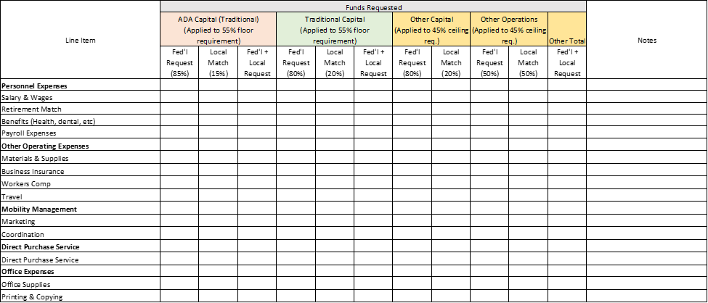
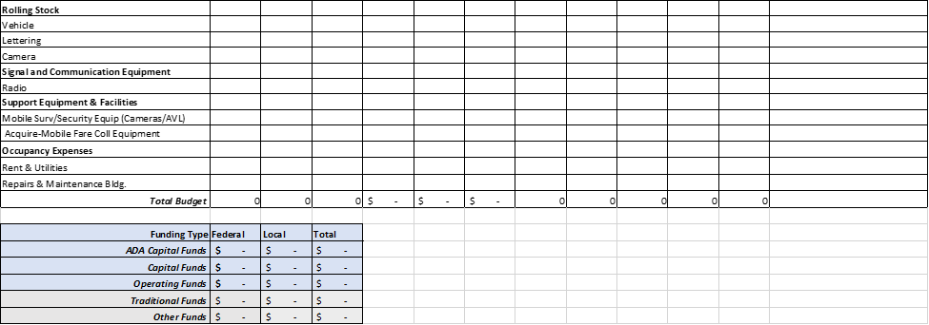
*Modify as needed if the applicant is seeking a 90% Federal, 10% local match funding split for vehicle related equipment and facilities.
Note: The applicant must demonstrate a commitment to provide local funds and provide appropriate documentation. Documentation may be in the form of a letter or other supporting documentation noting where funds will be drawn from.
Prior to any applications for a request to receive and use federal funds, the project needs to demonstrate that it meets all local, state and FTA requirements and that it is eligible to receive federal funds. Any match funding source outside the standards established by FTA must receive written approval from FTA to be used. Match funding should adhere to the following:
- Must be from an eligible funding source under FTA guidelines;
- Must be available at the time of the grant award;
- Match funding must be spent to qualify as a match;
- No federal funds may be drawn without authorization and availability of a sufficient match funding source;
- Subrecipients must certify the use of local match with the submission of each invoice;
- Subrecipients are required to provide quarterly reports that account for the use of local funds as match.
If needed, applicants should include an explanation to clarify a line item so that the request is easily understood. Some items that required further explanation:
  - Requests for personnel: provide title, number of hours for section 5310 project tasks, and wage rate
  - If a request is made for an item that is used for multiple project/organizational purposes, so that it is not used exclusively for Section 5310 project tasks, denote what percentage (1-100%) of the requested funds will be directly associated with carrying out Section 5310 program tasks. Also, denote if the dollar value of the fund request is for the full cost of the requested line item or the prorated cost of the line item (the proportion of the fund request solely associated with Section 5310 project costs).
  - Clustered line items: items such as “supplies,” “materials,” etc. need to be individually clarified so that it is readily apparent what the items requested are.

B. Local Match Documentation
Applicants must demonstrate a commitment to provide local funds and provide appropriate documentation. Documentation may be in the form of a letter or other supporting documentation noting where funds will be drawn from.
Match documentation should be submitted with this package with the following naming convention [OrganizationName]_Match2026.
Select the option that verifies whether a local funds match document has been submitted with this application.
○ Yes, submitted
○ No, not submitted

C. Eligible Projects Table
Traditional Projects | Nontraditional Projects
Funds can be applied to:  - Rolling stock/vehicle procurement, rehabilitation, or maintenance (buses and vans)  - Equipment (wheelchair lifts, ramps, and securement devices)  - Transit-related Information Technology  - Passenger facilities and amenities  - Mobility management and coordination programs  - Acquisition of transportation services under a contract, lease, or other arrangement. All capital and operating costs associated with contracted service are eligible capital expenses. | Funds can be applied to:  - Projects that seek to reduce barriers to transportation services and expand mobility options (travel training, volunteer driver programs)  - Exceed ADA requirements (enhanced paratransit services  - Improve access to fixed route service (sidewalks, curb cuts, wayfinding, technology, travel training etc.)  - Voucher, volunteer driver or taxi programs  - Incremental cost of providing same day service or door-to-door service

An itemized budget should be submitted with this package with the following naming convention [OrganizationName]_Budget2026. Applicants are encouraged to use the downloadable budget template file available on the GoRaleigh Call for Projects website.

Select the option that verifies whether an itemized budget has been submitted with this application.
○ Yes, submitted
○ No, not submitted
D. Lease Certification
If an applicant is requesting funding for an item that requires a lease, documentation is required to verify that the lease of equipment is more cost effective than purchase. Note that when lease of equipment or facilities is treated as a capital expense, the recipient must establish criteria for determining cost effectiveness in accordance with Office of Management and Budget (OMB) Circular No. A-94, Appendix D, which provides the necessary discount factors and formulas to be applied.
Please submit a separate file ([OrganizationName]_Lease2026) that demonstrates the lease of equipment is more cost-effective than purchase. The documentation should provide a comparison of the total costs of equipment purchased compared to the total cost of equipment leased over the applicants designated time-period of use.
If requesting funding for equipment leases, select the option that verifies whether financial documentation has been provided to demonstrate the lease of equipment is more cost-effective than purchase.
○ Yes, submitted
○ No, not submitted

Part IV - Modified Total Direct Cost (MTDC) Worksheet
Applicants submitting a de minimis indirect cost rate must provide documentation for their Modified Total Direct Cost. Please complete the worksheet below and include it as part of your application.
Modified Total Direct Cost (MTDC) Worksheet
If the applicant does not have a current negotiated federal indirect rate, the applicant may apply a de minimis rate of up to fifteen percent of its modified total direct costs (MTDC). If chosen, the applicant must use this method and rate consistently for all Federal awards. The applicant must consistently charge all costs as either direct or indirect costs.
CFR § 200.1 states that Modified Total Direct Cost (MTDC) “means all direct salaries and wages, applicable fringe benefits, materials and supplies, services, travel, and subawards and subcontracts up to the first $50,000 of each subaward or subcontract (regardless of the period of performance of the subawards and subcontracts under the award). MTDC excludes equipment, capital expenditures, charges for patient care, rental costs, tuition remission, scholarships and fellowships, participant support costs and the portion of each subaward and subcontract in excess of $50,000. Other items may only be excluded when necessary to avoid a serious inequity in the distribution of indirect costs, and with the approval of the cognizant agency for indirect costs.”
Please complete the table below to calculate your organization’s MTDC and de minimis indirect costs.

Modified Total Direct Costs Worksheet
Total allowable salaries and wages
Total associated fringe benefits
Total materials and supplies costs
Total services costs
Total travel costs
Total Subawards/subcontracts up to $50,000
Total Modified Direct Cost (MTDC) Base of Grant
Proposed de minimis rate. Percentage cannot exceed 15%.
MTDC Base x % = allowable de minimis indirect cost amount.

Appendix A – Documentation Required

Required Documents
These items will be required to be submitted if a project is awarded.
Reference Documents – References for Grant Requirements (please note that this list is not exhaustive and is subject to change as local, state and federal regulations change). The subrecipient is responsible for adhering to all federal, state and local grant requirements).
- Office of Management and Budget (OMB) Guidance for Federal Financial Assistance - 2 CFR part 200
- Federal Transit Administration Master Agreement
- Procurement (FTA Circular 4220.1G)
Please provide the following documents, if applicable to your agency. For each document, please provide the most recent completed, unless otherwise stated. For those items where you do not have an official written policy or manual, please provide a brief narrative describing your current process.
Annual Audited Financial Statements (if new subrecipient, provide copies of last 3 fiscal years)
Form 990 (most recently filed)
State Reports (State Reviews, State Maintenance)
Triennial Review Report
Other Reports (any federal/state/audit reports not listed above)
Board of Directors – List of members and Bios
Federal Tax Liability and Recent Felony Convictions Certification
Procurement Manual
Written Standards of Conduct (including conflict of interest policy)
Agency Organizational Chart
Organizational Chart for division(s) that manage financial and programmatic aspects of grant
Title VI Notice & Program
Americans with Disability Act Policy
Drug & Alcohol Policy and Testing – Drug-free Workplace
Transit Vehicle Manufacturer (TVM) Certification/Reporting
Asset Management Policy
FTA Funded Asset Listing – Inventory, Depreciation, Maintenance
Seat Belt Use Policy
Distracted Driver’s Policy
Safety and Security Procedures Process for safeguarding equipment and valuable assets
Protection of Sensitive Information Policy – Process for safeguarding eligibility documentation for program participants and related personally identifiable information (PII)
Indirect Cost Plan (please note that subaward is dependent upon approval of the indirect cost plan by the FTA.

Appendix B – Financial Management

Financial Expectations
Reimbursement packet with all required documentation (including support for all expenses) must be submitted to GoRaleigh no later than 30 days after quarter end.
Payments will be processed within 30-45 days after reimbursement requests are received. If there are errors in the reimbursement packet or additional documentation is needed, additional time may be needed to process the reimbursement request.
Procurements – When using federal funds for securing goods and/or services, all procurement activities must be compliant with Federal laws and regulations. Refer to FTA Circular 4220.1G for guidance.
Eligible Cost Requirements - refer to Reference Document list in application materials
- Consistent with description and scope of each project, the award budget, federal grant requirements, the underlying agreement and any related amendments
- Costs are necessary to carry out the award
- Costs are reasonable for the property or services for use in the project
- The actual net costs, which consists of the price paid minus any reduction of costs incurred, such as refunds, rebates, or other items of value, but excluding program income
- Costs incurred within period of performance beginning and end dates
- Costs are satisfactorily documented
- Costs are consistent with federally approved accounting principles and procedures
- Costs are consistent with US Department of Transportation Common Rules and other federal law, regulations, requirements, and guidance
Ineligible Costs -
- Costs outside of the performance period beginning and end dates
- Cost not included in award budget
- Costs for property or services with third party agreement lacking FTA approval
- Any ordinary governmental or operating cost not applicable to the award as prohibited by 49 U.S.C. § 5323(h)(1);
- A profit or fee for services provided by the recipient (subrecipient) in implementing the award
- Costs that are ineligible for FTA participation as provided in applicable federal law, regulation, or guidance

Required Documentation/Requirements for Reimbursement
- Letter of Invoice – This document provides the reimbursement amount requested and certifies the total 5310 eligible expenses for the period. Required with all reimbursement requests. (Exhibit A)
- Program Narrative – Program narrative that describes services performed during the reimbursement period. Required with all reimbursement requests. (Exhibit B)
- Subrecipient is required to submit the excel reimbursement template with every reimbursement request. (Exhibit C)
- Payroll - If requesting direct or indirect reimbursement for salaries and payroll related items, the following documentation is required. It can be submitted in electronic format (preferred) or hard copy.
  - Time Sheets & Payroll Reports – Time sheets and payroll reports should identify actual time spent working on Section 5310 grant activities, instead of estimated time on the grant. If subrecipient allocates time to multiple grants/resources, time sheets detailing time spent in each area are required.
  - Reconciliation of payroll report to excel reimbursement template
  - Reconciliation of payroll to General Ledger report
- Program Expenditures – Detailed documentation for program expenditures is required. Documentation should be easily labeled and may include the following:
  - Invoices
  - Receipts
  - Vouchers
  - Approvals
  - Vehicles – If purchasing vehicles, backup documentation should include pre/post audit certifications, insurance, title, and inventory/asset reports identifying the equipment
  - Buy America certification, if applicable
- Excel versions of documents should be submitted to show any calculations/formulas, when applicable.
- Subrecipient must reconcile program expenditures to excel reimbursement template – Each support page must be marked with a letter (A, B, C…) and the letter will tie back to the second column in the Excel reimbursement template. Subrecipient must coordinate with Raleigh’s program manager if they would like to request to use a different method of labeling supporting documentation.
- Rounding requirements – Amounts should be rounded at final calculation. Do not round components of the calculation. Show percentages at three decimal places and dollar amounts at two decimal places. If submitting a PDF document which includes calculations, then an Excel version must also be provided.
- Indirect Cost Plan – If subrecipient has an approved indirect cost plan for federal grants, GoRaleigh must obtain FTA approval of the indirect cost plan before any reimbursements are processed. Indirect costs will not be reimbursed without prior FTA approval. 2 CFR 200.403 and 2 CFR 200.414
- Indirect costs – Indirect costs can be charged by one of three methods – an approved Indirect Cost Rate Plan, the De Minimus rate, or a percentage based on time spent on the grant with proper payroll documentation. Expenses reimbursed as part of the indirect costs plan should not also be requested for reimbursement as a direct expense.
- In-Kind Services / Donated services / Volunteer services (may be used for non-cash match) Volunteer services must be accounted for at a reasonable rate based on what other employees within the agency are paid and general market comparison for similar duties.
- As part of GoRaleigh’s monitoring activities, agencies will be asked to provide listings of program participants and their related eligibility documentation (seniors 65 and over and/or persons with disability). Provide updates as new program participants are added to the program. Agencies are expected to retain documentation and safeguard for onsite monitoring.
- Mileage – Backup should include a description identifying trip purpose along with mileage supported by Google maps, Mapquest, etc.
- Record Retention – Records should be retained from authorized performance period until three years after the recipient has submitted its last or final expenditure report and other pending matters are closed. Formats or records may be electronic, email, paper and other formats as approved by FTA. Records must be accessible for review and stored separate from other records not related to the award to the extent feasible.

Exhibit A – Letter of Invoice

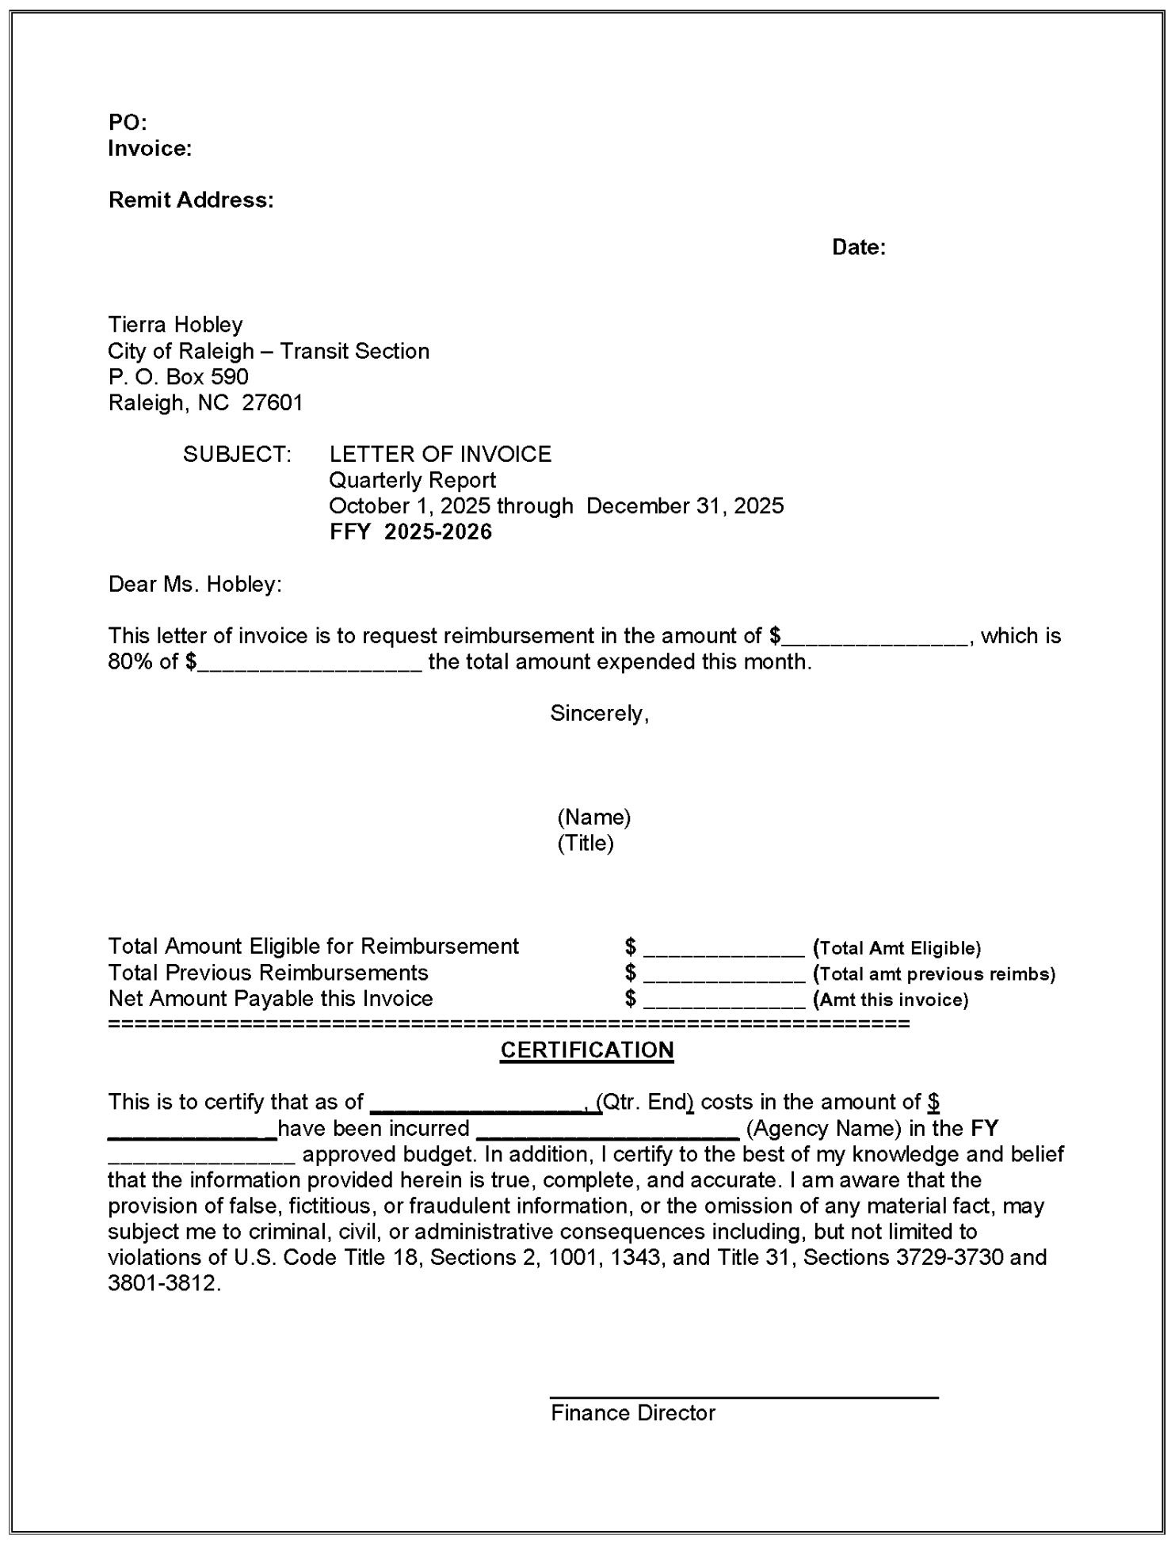
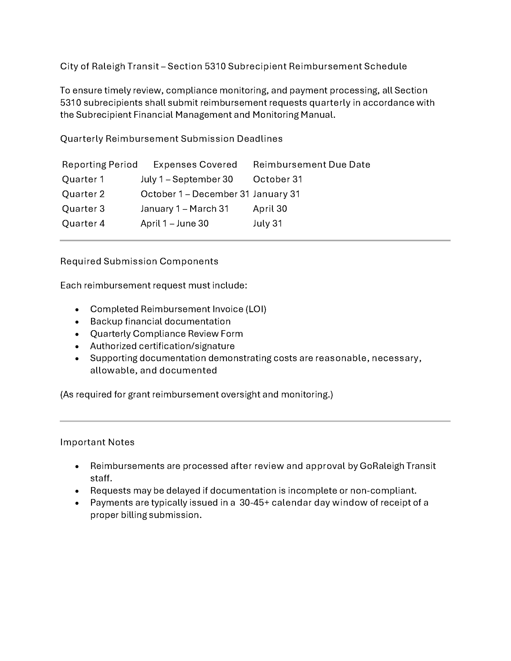

Exhibit B – Program Narrative PO Number: __________

DATE OF REPORT:
REPORT NUMBER: 1st Quarter 2nd Quarter 3rd Quarter 4th Quarter

QUARTERLY NARRATIVE PROGRESS REPORT

FOR QUARTER: October 1, 20XX TO December 31, 20XX

RETURN PROGRESS REPORT TO:

Tierra Hobley
City of Raleigh – Transit Section
P. O. Box 590
Raleigh, NC 27601

1. TITLE OF PROJECT:

2. AGENCY:

3. NAME, TITLE, AND PHONE NUMBER OF PERSON COMPLETING REPORT (signature required at end of report):

4. NARRATIVE OF WORK COMPLETED DURING THIS QUARTER
(attach additional sheets if needed):

____________________________
Signature

FOR OFFICE USE ONLY: Date Report Received: ____________

Report Received by: _______________________ COMMENTS: ___________________________________

________________________________________________________________________________________

Exhibit C – Reimbursement Template (downloadable file separately available)

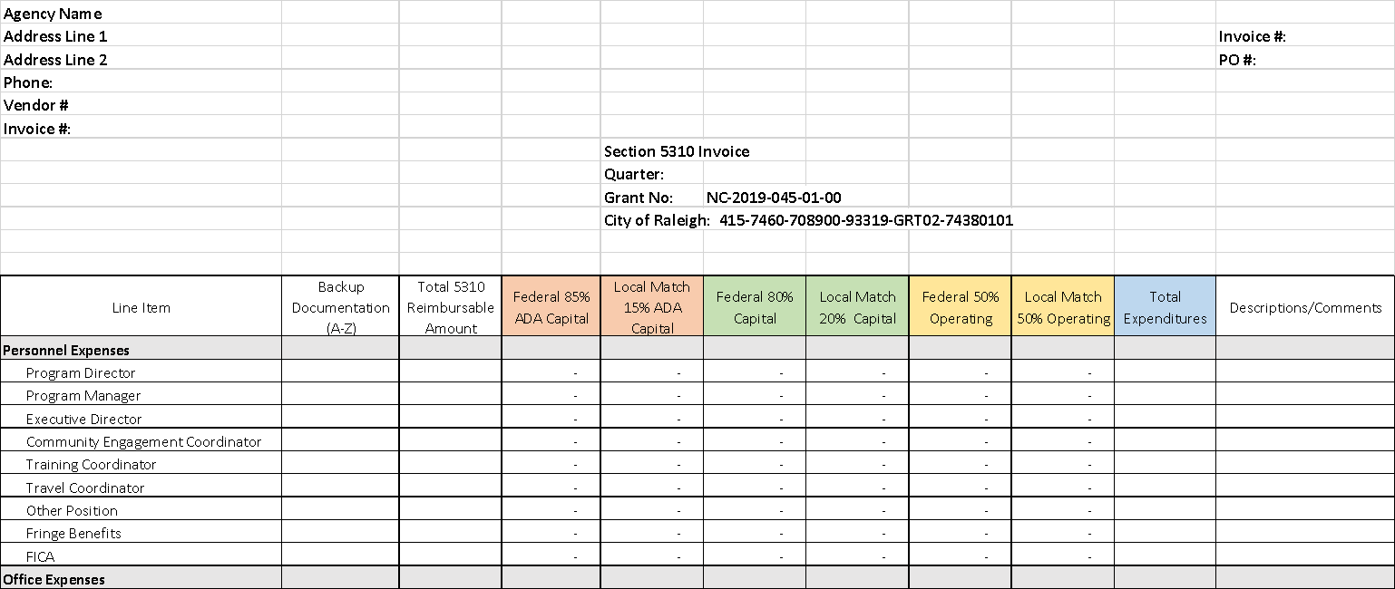
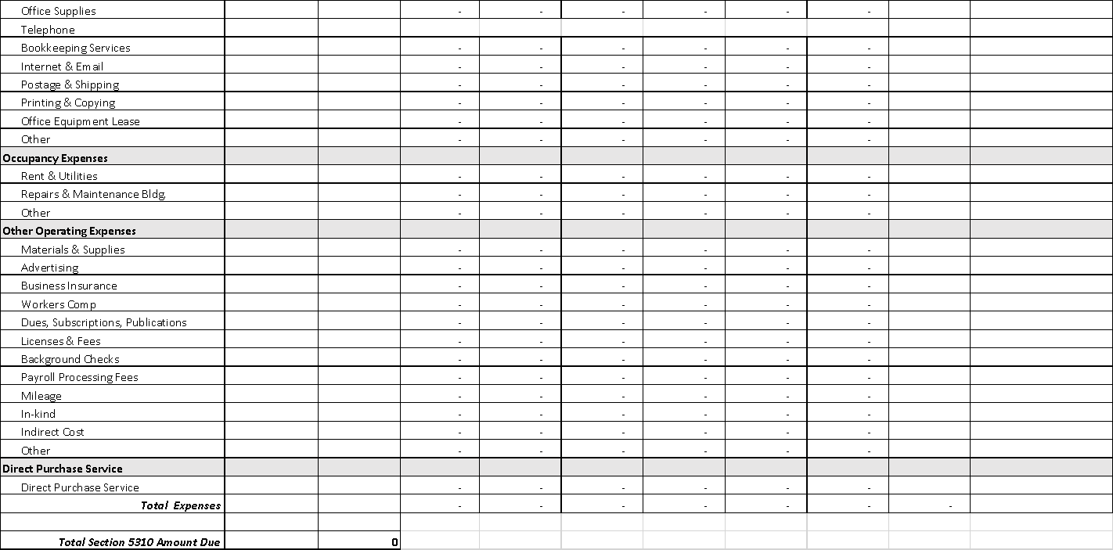

Appendix C – Additional Detail on Eligible Projects from FTA Section 5310 Guidance

This appendix provides additional detail on eligible projects from Section IV from FTA’s ENHANCED MOBILITY OF SENIORS AND INDIVIDUALS WITH DISABILITIES PROGRAM GUIDANCE (FTA C 9070.1H, updated 2024).

Traditional Capital Expenses
Examples of expenses that FTA classifies as traditional “capital” expenses include but are not limited to:
- Rolling stock and related activities for Section 5310-funded vehicles
- Acquisition of expansion or replacement buses or vans, and related procurement, testing, inspection, and acceptance costs;
- Vehicle rehabilitation or overhaul;
- Preventive maintenance;
- Radios and communication equipment; and;
- Vehicle wheelchair lifts, ramps, and securement devices.
- Passenger facilities related to Section 5310-funded vehicles
- Purchase and installation of benches, shelters and other passenger amenities.
- Support facilities and equipment for Section 5310-funded vehicles
- Extended warranties that do not exceed industry standard;
- Computer hardware and software;
- Transit-related intelligent transportation systems (ITS);
- Dispatch systems; and
- Fare collection systems.
- Lease of equipment when lease is more cost effective than purchase. Requirements regarding leases are governed by the Uniform Guidance, 2 CFR Part 200. Please see FTA Circular 5010.1 for a summary of requirements related to leasing.
- Acquisition of Transportation Services under a Contract, Lease, or Other Arrangement. This may include acquisition of ADA complementary paratransit services when provided by an eligible recipient or subrecipient as defined in Chapter III. Both capital and operating costs associated with contracted service are eligible capital expenses. User-side subsidies/vouchers for alternatives to public transportation are considered one form of eligible arrangement. All services must meet all Federal civil rights requirements, including those requiring equivalent service to persons with disabilities, particularly wheelchair users, in the provision of demand-responsive service and any ADA Title II program access responsibilities administered by the U.S. Department of Justice. Funds may be requested for contracted services covering a time period of more than one year. The capital eligibility of acquisition of services as authorized in 49 U.S.C. 5310(b)(4) is limited to the Section 5310 program.
- Support for Mobility Management and Coordination Programs among Public Transportation Providers and Other Human Service Agencies Providing Transportation. Mobility management is an eligible capital cost. Mobility management techniques may enhance transportation access for populations beyond those served by one agency or organization within a community. For example, a nonprofit agency could receive Section 5310 funding to support the personnel costs of sharing services it provides to its own clientele with other seniors and/or individuals with disabilities and to coordinate usage of vehicles with other nonprofits; however, operating costs of service are excluded. Mobility management is intended to build coordination among existing public transportation providers and other transportation service providers with the result of expanding the availability of service. Mobility management activities may include:
- The promotion, enhancement, and facilitation of access to transportation services, including the integration and coordination of services for individuals with disabilities, seniors, and low-income individuals;
- Support for short-term management activities to plan and implement coordinated services;
- The support of State and local coordination policy bodies and councils;
- The operation of transportation brokerages to coordinate providers, funding agencies, and passengers;
- The provision of coordination services, including employer-oriented transportation management organizations’ and human service organizations’ customer-oriented travel navigator systems and neighborhood travel coordination activities such as coordinating individualized travel training and trip planning activities for customers;
- The development and operation of one-stop transportation traveler call centers to coordinate transportation information on all travel modes and to manage eligibility requirements and arrangements for customers among supporting programs; and
- Operational planning for the acquisition of intelligent transportation technologies to help plan and operate coordinated systems inclusive of geographic information systems (GIS) mapping; global positioning system technology; coordinated vehicle scheduling; dispatching and monitoring technologies; technologies to track costs and billing in a coordinated system; and single smart customer payment systems. (Acquisition of technology is also eligible as a standalone capital expense).
Capital activities (e.g., acquisition of rolling stock and related activities, acquisition of services, etc.) to support ADA-complementary paratransit service may qualify as traditional expenses, so long as the service is provided by an eligible recipient/subrecipient as defined in the 5310 Program Management Plan and is included in the Coordinated Public Transit - Human Services Transportation Plan.
As a reminder, the GoRaleigh Section 5310 Program Management Plan restricts eligibility for vehicle (rolling stock) purchases to:
- Organizations that are also direct recipients of FTA funds, as well as
- Government entities and agencies that have historically received funds from FTA and compliance oversight from NCDOT.

Other Expenses
Up to 45 percent of Section 5310 funds may be used for operating expenses that provide transportation services that exceed the requirements of the ADA or improve access to fixed route services and decrease reliance by persons with disabilities on ADA complementary transit service. These expenses include the following:
- Public transportation projects (capital only) planned, designed, and carried out to meet the special needs of elderly persons and persons with disabilities when public transportation is insufficient, inappropriate, or unavailable;
- Public transportation projects (capital and operating) that exceed the requirements of ADA;
- Public transportation projects (capital and operating) that improve access to fixed route service and decrease reliance by persons with disabilities on ADA-complementary paratransit service; or
- Alternatives to public transportation (capital and operating) that assist elderly persons and persons with disabilities with transportation.

Projects that Exceed the Requirements of the ADA
The following activities are examples of eligible projects meeting the definition of public transportation service that is beyond ADA requirements. This list is not exhaustive.
- Enhancing paratransit beyond minimum requirements of the ADA. ADA-complementary paratransit services can be eligible under the Section 5310 program in several ways:
  - Expansion of paratransit service parameters beyond the three-fourths mile required by the ADA;
  - Expansion of current hours of operation for ADA paratransit services that are beyond those provided on the fixed-route services;
  - The incremental cost of providing same-day service;
  - The incremental cost (if any) of making door-to-door service available to all eligible ADA paratransit riders, but not on a case-by-case basis for individual riders in an otherwise curb-to-curb system;
  - Enhancement of the level of service by providing escorts or assisting riders through the door of their destination;
  - Acquisition of vehicles and equipment designed to accommodate mobility aids that exceed the dimensions and weight ratings established for wheelchairs under the ADA regulations, 49 CFR part 38 (i.e., larger than 30″ × 48″ and/or weighing more than 600 pounds), and labor costs of aides to help drivers assist passengers with oversized wheelchairs. This would permit the acquisition of lifts with a larger capacity, as well as modifications to lifts with a 600-pound design load, and the acquisition of heavier duty vehicles for paratransit and/or demand-response service in order to accommodate lifts with a heavier design load; and
  - Installation of additional securement locations in public buses beyond what is required by the ADA.
- Feeder services. Accessible “feeder” service (transit service that provides access) to commuter rail, commuter bus, intercity rail, and intercity bus stations, for which complementary paratransit service is not required under the ADA.

Public Transportation Projects that Improve Accessibility
The following activities are examples of eligible projects that improve accessibility to the fixed-route system. This list is not exhaustive.
- Making accessibility improvements to transit and intermodal stations not designated as key stations. Improvements for accessibility at existing transportation facilities that are not designated as key stations established under 49 CFR 37.47, 37.51, or 37.53 and that are not required under 49 CFR 37.43 as part of an alteration or renovation to an existing station, so long as the projects are clearly intended to remove barriers that would otherwise have remained. Section 5310 funds are eligible to be used for accessibility enhancements that remove barriers to persons with disabilities so they may access greater portions of public transportation systems, such as fixed-route bus service, commuter rail, light rail, and rapid rail. This may include:
  - Building an accessible path to a bus stop that is currently inaccessible, including curb cuts, sidewalks, accessible pedestrian signals, or other accessible features;
  - Adding an elevator or ramps, detectable warnings, or other accessibility improvements to a non-key station that are not otherwise required under the ADA;
  - Improving signage or wayfinding technology;
  - Implementation of other technology improvements that enhance accessibility for people with disabilities including ITS;
  - Travel training. Training programs for individual users on awareness, knowledge, and skills of public and alternative transportation options available in their communities. This includes travel instruction and travel training services.

Alternatives to Public Transportation that Assist Elderly Persons and Persons with Disabilities with Transportation
The following activities are examples of projects that are eligible alternatives to public transportation. This list is not exhaustive.
- Purchasing vehicles to support accessible taxi, ride-sharing, and/or vanpooling programs. Section 5310 funds can be used to purchase and operate accessible vehicles for use in taxi, ride-sharing, and/or vanpool programs provided that the vehicle meets the same requirements for lifts, ramps, and securement systems specified in 49 CFR part 38, subpart B, at a minimum, and permits a passenger whose wheelchair can be accommodated pursuant to Part 38 to remain in his/her personal mobility device inside the vehicle.
- Supporting the administration and expenses related to voucher programs for transportation services offered by human service providers. This activity is intended to support and supplement existing transportation services by expanding the number of providers available or the number of passengers receiving transportation services. Vouchers can be used as an administrative mechanism for payment of alternative transportation services to supplement available public transportation. The Section 5310 program can provide vouchers to elderly persons and persons with disabilities to purchase rides, including: (a) mileage reimbursement as part of a volunteer driver program; (b) a taxi trip; or (c) trips provided by a human service agency. Providers of transportation can then submit the voucher for reimbursement to the recipient for payment based on predetermined rates or contractual arrangements. Transit passes or vouchers for use on existing fixed-route or ADA complementary paratransit service are not eligible. Vouchers are an operational expense which requires a 50/50 (federal/local) match.
- Supporting volunteer driver and aide programs. Volunteer driver programs are eligible and include support for costs associated with administration, management of driver recruitment, safety, background checks, scheduling, coordination with passengers, other related support functions, mileage reimbursement, and insurance associated with volunteer driver programs. The costs of enhancements to increase capacity of volunteer driver programs are also eligible. FTA encourages communities to offer consideration for utilizing all available funding resources as an integrated part of the design and delivery of any volunteer driver/aide program.

Appendix D – FTA Reference Guide for Select Topics

This appendix lists topics from previous grant application cycles that many applicants had questions about, along with applicable excerpts from FTA’s 5310 Program Circular (FTA C 9070.1H, updated 2024).
Note that procurement requirements outlined in 2 CFR 200 may also apply or supersede requirements identified in the FTA Circular.
Leasing Vehicles Acquired with Section 5310 Funds
See excerpt from Chapter VI-4 of FTA’s 5310 Program Circular below:
Vehicles acquired under the Section 5310 program may be leased to other entities such as local governmental authorities or agencies, other private nonprofit agencies, or private for- profit operators. Under such a lease, the lessee operates the vehicles on behalf of the Section 5310 subrecipient and provides transportation to the subrecipient’s clientele as described in the grant application.
The lease between the Section 5310 subrecipient and the lessee contains the terms and conditions that must be met in providing transportation service to seniors and people with disabilities. Because the purpose of the Section 5310 grant is to provide transportation service to seniors and people with disabilities, other uses of the vehicle are permitted only as long as such uses do not interfere with service to seniors and people with disabilities.
The recipient, being responsible for ensuring that the terms and conditions of the original Award with FTA are met, must agree, in writing, to each lease between the subrecipient and the lessee. Such an agreement should specify that the leased vehicle shall be used to provide transportation service to seniors and people with disabilities and that the vehicle may be used for incidental purposes only after the needs of these individuals have been met.
Recipients may lease any of their assets to others on an incidental basis so long as the lease agreement holds the lessee responsible for compliance with all of the requirements the recipient itself is responsible for. Thus, the lessee must adhere to applicable and relevant terms and conditions of FTA’s master agreement in the maintenance and use of the asset. For example, a recipient may not lease its revenue vehicles to a private
Meal Delivery Services
See excerpt from Chapter VI-3 of FTA’s 5310 Program Circular below:
Under the Incidental Use policy, transit service providers receiving assistance under this section may coordinate and assist in providing meal delivery services for homebound people on a regular basis, if the meal delivery services do not conflict with the provision of transit services or result in a reduction of service to transit passengers. The number and size of vehicles applied for under Section 5310 must be determined only by the number of passengers to be transported, not meal delivery capacity. Section 5310 funds may not be used to purchase special vehicles to be used solely for meal delivery or to purchase specialized equipment, such as racks or heating or refrigeration units, related to meal delivery. For further information regarding incidental use, please refer to FTA Circular 5010.1.
Printers / Copiers
Printers/ copiers are considered administrative cost which is an allowable up to 10% of allocated FTA Funds.
See excerpt from Chapter III-7 of FTA’s 5310 Program Circular below:
Allowable administrative costs may include, but are not limited to, general administrative and overhead costs, staff salaries, office supplies, and development of specifications for vehicles and equipment. Guidance on eligible administrative costs is in the Subpart E to 2 CFR Part 200, Cost Principles. The program administration budget line item also may include technical assistance and planning activities, including allocations to subrecipients to support the local coordinated planning process. Any general overhead costs included in the award budget must be supported by an indirect cost allocation plan that has been approved by the recipient or subrecipient’s cognizant agency for indirect costs or elect the de minimis rate, if eligible.
Equipment that is Shared between Section 5310 and other Uses
See excerpt from Chapter VI-3 of FTA’s 5310 Program Circular below:
FTA encourages maximum use of vehicles funded under the Section 5310 program. Consistent with the requirements under 2 CFR Part 200, vehicles are to be used first for program-related needs for which a Section 5310 Award is made and then to meet other Federal programs or project needs, providing these uses do not interfere with the project activities originally funded. If the vehicle is no longer needed for the original program or project, the vehicle may be used in other activities currently or previously supported by a Federal agency. Disposition information is included in FTA Circular 5010.1. States and their subrecipients should follow State laws and procedures for disposing of equipment. Note there are specific requirements under 49 U.S.C. 5334 pertaining to disposition, and these requirements are outlined in the current Award Management Circular (5010.1).
Vehicles may be used:
a. For Section 5310 Project and Program Purposes. Recipients should consider how best to meet the needs of all seniors and people with disabilities in a particular community in the recipient’s project selection process. The program must provide for maximum feasible coordination with transportation services assisted by other Federal sources. Subrecipients should be encouraged, to the extent feasible, to also provide service to seniors and people with disabilities not affiliated with their agency, as well as to the general public, on an incidental basis if such service does not interfere with transportation services for seniors and people with disabilities. In some situations, it may be appropriate to provide Section 5310 assistance to an agency to provide transportation exclusively to its own clients, but even in situations in which it is not feasible for the agency to provide services to those in the community beyond its own clients, that agency must, when practicable, make the vehicle itself available to provide transportation service to other seniors and people with disabilities at times the agency is not using the vehicle for award-related purposes. The recipient shall use the vehicle in the project or program for which it was acquired as long as needed, even if the project does not continue to receive Federal funding.
b. For Other Federal Programs or Project Purposes. During the period the vehicle is used to serve the project or program needs for which it was acquired, the recipient or subrecipient shall make it available for use on other projects or programs, as long as such other use does not interfere with the service for which the vehicle was originally acquired. First preference for such other use will be given to other projects or programs sponsored by FTA, and second preference will be given to projects or programs sponsored by other Federal agencies. Finally, vehicles may be used by non- federally funded providers, first to meet the needs of seniors and people with disabilities and then to serve the transportation needs of the general public on an incidental basis.
c. Incidental Use. Incidental use is when a recipient or subrecipient allows the use of federally funded assets by another entity for non-public transit purposes. Incidental use of federally funded assets is permitted for recipients of funding under all FTA programs, including Section 5310. The incidental use cannot interfere with the purpose of the original grant (2 CFR 200.313). That is, the non-transit activity may not reduce or limit transit service provided with those same assets. Incidental use, by definition, is not public transportation. Thus, it is impossible for an incidental use trip to be a public transportation trip. FTA is required to exclude service data for incidental use from the apportionment of formula grants.
Mobility Management as Traditional (Capital) vs. Nontraditional (Operational)
Mobility Management appears as an eligible expense under both the “Traditional” and “Other” 5310 categories in the 5310 Circular.

Mobility Management is a practice that:
  - Captures mobility needs and develops solutions
  - Links and coordinates transportation resources
  - Connects resources to people for easy access

Mobility Management activities classified as Traditional Capital Expenses includes:
  - The promotion, enhancement, and facilitation of access to transportation services
  - Support for short-term management activities to plan and implement coordinated services
  - Trip planning and coordination
  - Travel training
  - Transportation navigation assistance
  - Information and referral services
  - One-stop information
  - Regional coordination activities

Further information regarding eligible activities can be found on FTA Circular 9070.1H, Chapter IV.

