Raleigh Downtown Transportation Plan
The City of Raleigh, in partnership with CAMPO, GoTriangle, and NCDOT is leading the Raleigh Downtown Transportation Plan. This plan focuses on transit, transportation, and urban design recommendations for the urban core of Downtown Raleigh. The 2016 Wake Transit Plan created a vision for transit to connect the region and all Wake County communities by providing frequent, reliable urban mobility and enhancing access to transit. The Downtown Transportation Plan builds on the Wake Transit Plan by further developing the vision for transit and transportation in Downtown Raleigh by creating a multimodal transportation network that reflects a diverse spectrum of transportation needs including automobile, bicycle, pedestrian and public transportation users.

The goals for the Downtown Transportation Plan are:
- Develop a transit operations plan for Downtown Raleigh for the next 10 years, including the proposed Bus Rapid Transit (BRT) routes identified in the 2016 Wake Transit Plan.
- Identify various street sections that accommodate safe travel for all transit and transportation modes.
- Design within the context of existing plans, potential future development and future transit operations.
Study Process:
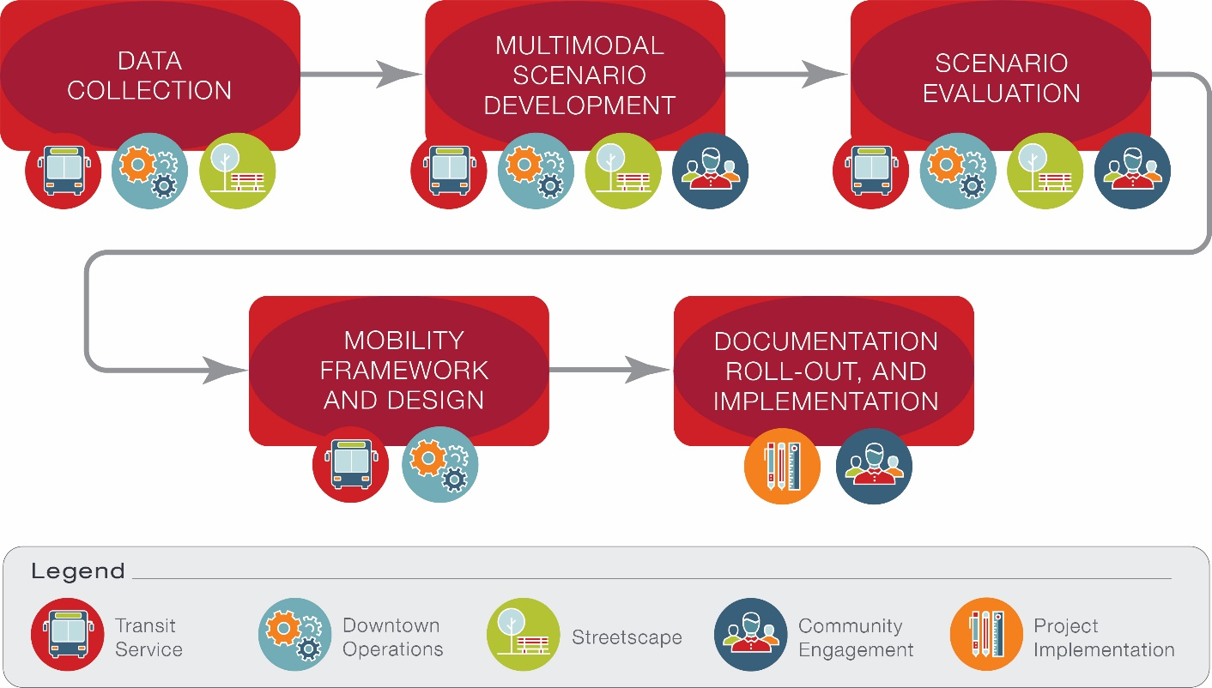
As described in the outline below, the process for this study includes developing various multimodal scenarios for the core of Downtown, evaluating these scenarios and designing a framework for implementation. The scenarios developed will include recommendations for transit service, Downtown operations, streetscape, and project implementation.
Engagement Strategy
Community engagement will be a priority throughout the duration of the project. The project team will be meeting with stakeholders and members of the community to provide information and gather feedback. Engagement activities include:
- Stakeholder Group Meetings
- Public Meetings
- Technical Team Meetings and Workshops
- Advisory Committee Meetings
- City Council Presentations and Meetings
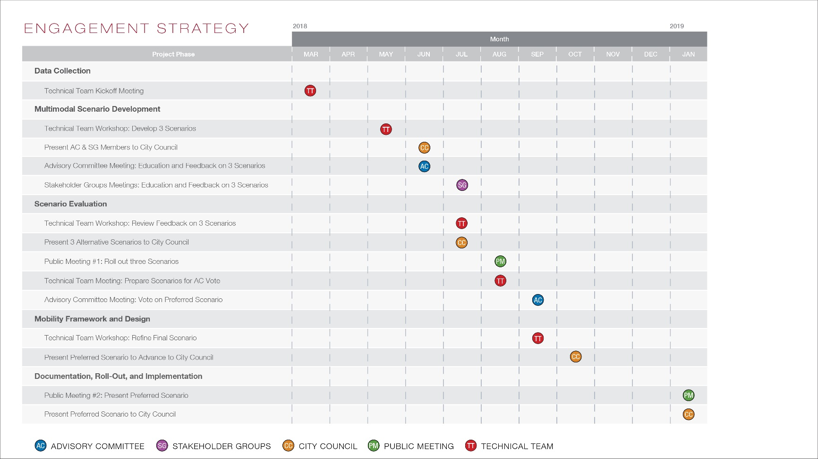
The table below provides a schedule for the stakeholder and community engagement events that will be taking place throughout 2018 and early 2019.

Engagement Group Descriptions
Stakeholder Groups (SG)
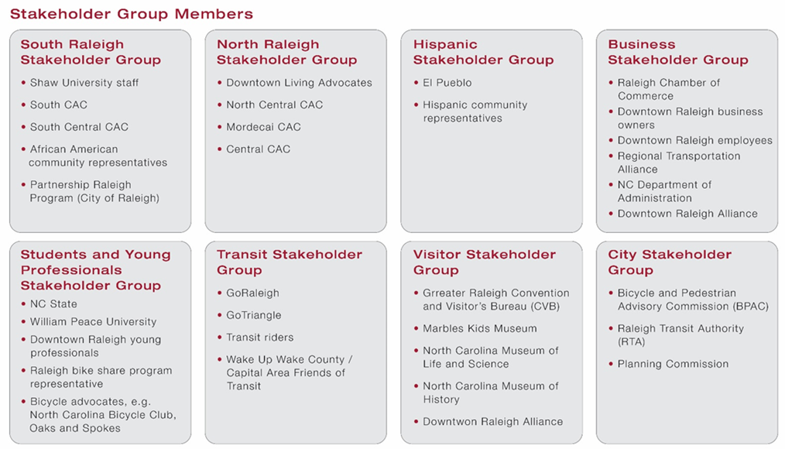
The Stakeholder Groups will provide input from the perspective of the community. The SGs will consist of representatives from public and private sector interest groups, Citizens Advisory Councils (CACs), and key stakeholders in Downtown Raleigh. A meeting will be held with each SG to learn about the trade-offs and provide input on high-level priorities as well as specific needs, desires, and concerns of these sub-groups. Members of the Stakeholder Groups will be representatives from the following entities:
Technical Team (TT)
The Technical Team is the primary reviewing body of the deliverables prepared throughout the study. This team will provide detailed feedback prior to material distribution to other stakeholders. The Technical Team includes staff from the City of Raleigh, GoTriangle, CAMPO, NCDOT, and the Downtown Raleigh Alliance (DRA). The Technical Team members will review materials independently, and are anticipated to meet as needed throughout the project to discuss technical issues.
Public Meetings (PM)
All members of the public will be invited to these meetings. The purpose of the meetings will be for the public to learn about the trade-offs associated with different scenarios, provide input on high-level priorities and potential scenarios, and remain educated on the study.
City Council (CC)
The role of City Council will be to stay informed and provide input and oversight throughout the study.

Advisory Committee (AC)
The Advisory Committee consists of citizens representing various interests and demographics in Downtown Raleigh. The purpose of the AC is to provide representation from across the downtown area and offer decision guidance at key milestones throughout the project. The AC is anticipated to include up to 20 members, and will include leadership from City and Downtown groups. The following representatives were invited to serve on the AC.
Advisory Committee Members List:
Name | Represents
Joe Milazzo | RTA/Chamber
Karen Rindge | WakeUp Wake County
John Kane | Developer
Joe Whitehouse | Capital Area Ride for Safety (CARS)
Leo Suarez | Downtown Living Advocates (DLA)
Richard Hancock | NCDOT
Jason Horne | Raleigh Transit Authority
Robert Owens | Resources for Seniors
Cody Stokes | Oaks and Spokes, Tactical Committee for Cycle Track Project
Dr. Keith Powell | Shaw University
Jannet Barnes | African American Caucus
Kris Larson | Downtown Raleigh Alliance (DRA)
Brian Ralph | William Peace University
John Crawford | NC Department of Administration (NCDOA) – Parking and Transportation
Debbie Collins | NCDOT Public Transportation Division (PTD)
Nicole Kreiser | Wake County

